VINH UNIVERSITY
SCHOOL OF ENGINEERING AND TECHNOLOGY



PROJECT REPORT ON
SOFTWARE ENGINEERING

DEVELOP AN ONLINE CLASSROOM MANAGEMENT SYSTEM

GROUP: 03

Instructor: | Cao Thanh Son, PhD.
Students: | Nguyen Dinh Thiep, 225748020110281 (Leader)
 | Le Quy Phuoc, 2257480201101
 | Nguyen Huu Hung, 2257480201243

Nghe An, 6/2026
ACKNOWLEDGEMENTS

During the process of completing the course project entitled “Developing an online classroom management system”, I would like to express my deepest and most sincere gratitude to Cao Thanh Son for his dedicated guidance, valuable advice, and continuous support throughout the development of this project. His insightful feedback, professional expertise, and strong sense of responsibility not only helped me successfully accomplish the project requirements but also provided me with practical knowledge and valuable experience in the field of software development.
I would also like to extend my sincere appreciation to all lecturers of the Faculty of Information Technology for their dedication in teaching and for equipping me with a solid academic foundation during my studies.
Although I made every effort to complete this project to the best of my ability, due to limitations in knowledge and practical experience, the project may still contain certain shortcomings. Therefore, I sincerely look forward to receiving constructive comments and suggestions from my supervisor and lecturers so that I can further improve and develop my work in the future.
Once again, I would like to express my heartfelt thanks to everyone who has supported and encouraged me throughout this project.

Once again, I would like to express my sincere thanks!

TABLE OF CONTENTS

LIST OF FIGURES 4
PREAMBLE 6
1.1. Reasons for choosing the topic 6
1.2. Research objectives 7
1.3. Research methodology 8
1.4. Thesis structure 9
CHAPTER 1. OVERVIEW OF THE ONLINE CLASSROOM MANAGEMENT SYSTEM 11
1.1. Introduction to online classroom management 11
1.2. Current Problems in Online Classroom Management 12
1.3. Objectives and scope of the system 14
1.4. System requirements 16
1.5. Overview of the proposed solution 19
CHAPTER 2. SYSTEM ANALYSIS AND DESIGN 22
2.1. Requirements analysis 22
2.2. Use case analysis 25
2.3. Database design 29
2.4. System architecture design 34
2.5. User interface design 38
CHAPTER 3. SYSTEM IMPLEMENTATION AND EVALUATION 42
3.1. Development environment and technologies 42
3.2. System implementation 46
3.3. Main functional modules 51
3.4. System testing and evaluations 62
3.5. Result and discussion 64
CONCLUSTIONS 66
1. Achievements 66
2. Limitations 67
3. Future Development 68
REFERENCES 69

LIST OF FIGURES
Fig 1.1. Smart-Room 7
Fig 1.2. Research Objective 8
Fig 1.3. Research Scope 9
Fig 1.4. Report Structure 10
Fig 1.4. Solution architecture 20
Fig 2.1. V-Model 24
Fig 2.1. Use case diagram 25
Fig 2.3. Data Management 29
Fig 2.3.2.1. Users table 30
Fig 2.3.2.2. Roles table 30
Fig 2.3.2.3. User_roles table 31
Fig 2.3.2.4. Departments table 31
Fig 2.3.2.4. meeting_rooms table 31
Fig 2.3.2.4. Devices table 32
Fig 2.3.2.4. bookings table 32
Fig 2.3.2.4. booking_attendees table 33
Fig 2.4. Real-Time Communication 37
Fig 2.5. Project Directory Structure and Organization 41
43
Fig 3.1. Java Programming Language 43
Fig 3.2. Spring boot Framework 44
Fig 3.3. MySQL Database 45
Fig 3.4. Login Page Interface 46
Fig 3.5. Registration Page Interface 47
Fig 3.6. Home Page Interface 48
Fig 3.7. Introduction Page Interface 49
Fig 3.8. Admin Interface 50
Fig 3.9. Meeting schedule page interface 51
Fig 3.10. Meeting schedule page interface 52
Fig 3.11. Contact page interface 53
Fig 3.12. Personal profile interface 54
Fig 3.13. Admin page for user management 55
Fig 3.14. Devices management page 56
Fig 3.15. Conferences management 57
Fig 3.16. Operations center 58
Fig 3.17. class schedule management 59
Fig 3.18. Classroom details 60

PREAMBLE

Reasons for choosing the topic
The global educational landscape has undergone a significant shift toward E-learning and remote collaboration in recent years, leading to a record-high demand for stable and user-friendly online classroom platforms. While many general-purpose tools exist, there is a continuous need for specialized systems like SmartRoom to streamline administrative tasks and provide high-quality interactive environments. Many current solutions feel fragmented, forcing educators to switch between different applications for video calls and student tracking. This project aims to bridge that gap by providing a unified platform that integrates secure authentication via Spring Security, low-latency video conferencing using WebRTC, and real-time messaging. Choosing this topic allows for the practical application of Agile/Scrum methodologies and full-stack development with Spring Boot and Thymeleaf. Furthermore, building this system provides a valuable opportunity to solve real-world problems regarding data security and interactive learning, which are crucial for the future of digital education.
To ensure software quality, the V-Model is utilized, emphasizing a rigorous testing phase for every development stage to resolve defects early in the lifecycle. The process involves a Verification Phase, covering requirement analysis, system architecture design, and detailed logic for real-time protocols. Parallel to this is the Validation Phase, where individual components undergo unit testing, followed by integration, system, and acceptance testing to ensure all features work harmoniously for the end-users.
The primary objective of this research is to design and implement a comprehensive management system that features a robust and scalable architecture. Technically, the goal is to master WebRTC for conferencing and WebSockets for data synchronization while applying the V-Model to minimize final product defects. Functionally, the system will provide full CRUD capabilities for virtual room management, unique room code generation, and a dedicated portal for role-based user management. Ultimately, the project seeks to create a highly interactive, cost-effective solution that meets the modern demands of digital transformation in the educational sector.
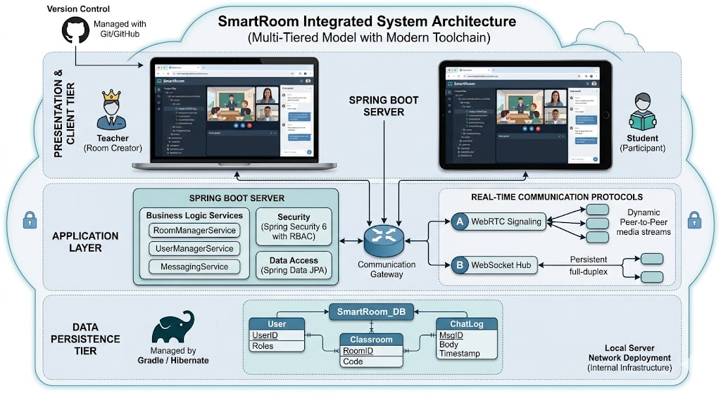
Fig 1.1. Smart-Room

Research objectives
The architectural design of the “SmartRoom” system follows a modern multi-tiered structure to ensure scalability, security, and real-time responsiveness. At the core of the system is the Web Server, built on the Spring Boot framework, which acts as the central hub for handling business logic and managing data flow. The backend integrates Spring Security to provide a robust authentication layer, ensuring that only authorized users can access specific classroom resources. For data persistence, a Database such as MySQL or PostgreSQL is utilized to store user profiles, room configurations, and persistent chat logs. A critical component of this architecture is the integration of WebRTC and WebSocket protocols; while WebRTC facilitates high-quality, peer-to-peer video and audio streaming, WebSockets enable low-latency, real-time communication for the instant messaging and live notification services. On the client side, the Frontend is developed using Thymeleaf templates and Bootstrap, providing a dynamic and responsive interface that allows users to interact seamlessly with the system across various devices. This architecture ensures that the system can handle concurrent classroom sessions effectively while maintaining data integrity and a smooth user experience.
Solving Real-world Problems: To provide a secure, cost-effective, and highly interactive solution for virtual education that meets the modern demands of digital transformation.
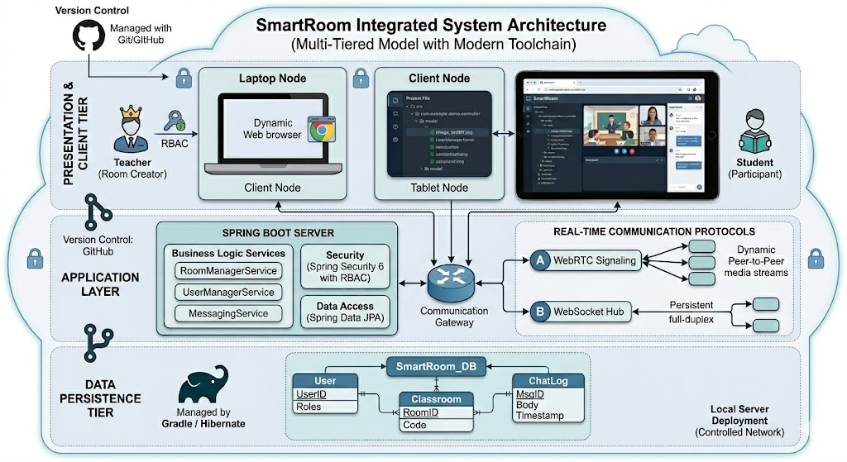
Fig 1.2. Research Objective

Research methodology
The research scope of this project is focused on the design and development of a web-based synchronization platform tailored for small to medium-sized virtual classrooms. Geographically and demographically, the study targets educational environments where real-time interaction is essential but does not require the massive infrastructure of enterprise-level systems. Technically, the scope is confined to the implementation of core features including user authentication, classroom creation, and real-time communication through WebRTC for video/audio and WebSockets for instant messaging. The system is designed to operate primarily on modern web browsers, ensuring accessibility without the need for additional software installation. While the project covers the full-stack development lifecycle—from requirement analysis using the V-Model to deployment on a local server environment—it does not extend to advanced features such as AI-driven proctoring, complex learning management system (LMS) integrations, or native mobile application development. By establishing these boundaries, the research ensures a deep and quality-focused implementation of the most critical functionalities required for an effective online learning experience.
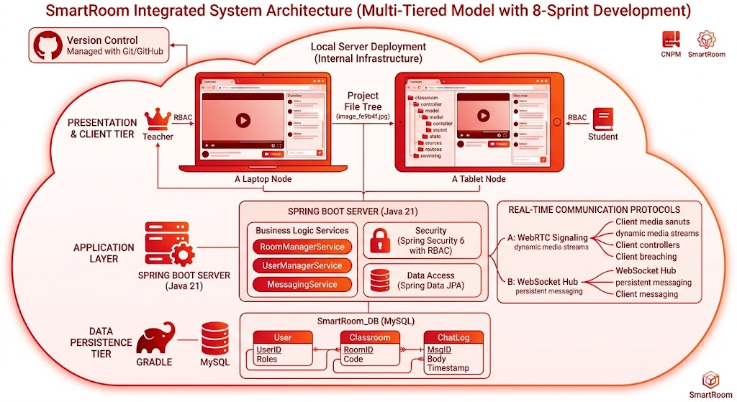
Fig 1.3. Research Scope

Thesis structure
The structure of this report is meticulously organized into three comprehensive chapters, providing a logical and academic progression from the theoretical foundation to the implementation and evaluation of the "SmartRoom" system.
Chapter 1: Overview of the SmartRoom System establishes the foundation of the study by introducing the concept of online classroom systems and real-time communication platforms. This chapter discusses the current challenges in online education and classroom management, defines the objectives and scope of the SmartRoom system, presents the system requirements, and provides an overview of the proposed solution. It clarifies the necessity of developing an integrated platform to support online teaching and learning effectively.
Chapter 2: System Analysis and Design focuses on the technical planning and architectural design of the SmartRoom system. This chapter includes requirement analysis, Use Case analysis to define user interactions, database design for managing system information, system architecture design, and user interface design. These components provide a complete blueprint for developing the system and ensure that both functional and non-functional requirements are satisfied.
Chapter 3: System Implementation and Evaluation presents the practical development process of the SmartRoom system. This chapter describes the development environment and technologies used, including Spring Boot, Spring Security, WebRTC, and WebSockets. It also explains the implementation of major functional modules, system testing and evaluation, and discusses the results achieved during deployment and experimentation.
Conclusion summarizes the achievements of the project, identifies existing limitations, and proposes future development directions to improve and expand the SmartRoom system.
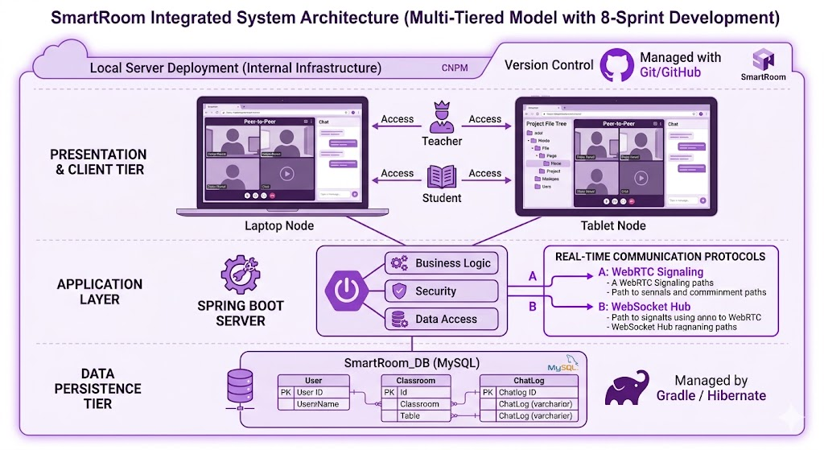
Fig 1.4. Report Structure

CHAPTER 1. OVERVIEW OF THE ONLINE CLASSROOM MANAGEMENT SYSTEM

1.1. Introduction to online classroom management
In the contemporary educational landscape, the rapid advancement of digital technologies and the profound shift towards remote collaboration have fundamentally transformed traditional pedagogical models. Online classroom management has emerged as a critical domain within educational technology, encompassing the administrative, technical, and instructional strategies required to orchestrate effective learning experiences in virtual environments. Unlike physical classrooms where interaction and oversight are inherently bound by spatial presence, digital learning spaces rely entirely on software infrastructure to facilitate communication, monitor student engagement, maintain academic discipline, and deliver instructional content synchronously or asynchronously.
Effective online classroom management extends beyond the mere delivery of live video streams; it requires an integrated ecosystem capable of mitigating the technical and administrative fragmentation that frequently hinders digital education. Educators in modern virtual settings face multifaceted challenges, including managing user access, establishing secure and authenticated environments, coordinating multi-user real-time communications, and sustaining administrative control over virtual spaces without disrupting the instructional flow. Consequently, the development of specialized software platforms dedicated to streamlining these administrative tasks while simultaneously fostering high-quality, low-latency interactive environments has become essential for educational institutions undergoing digital transformation.
Within the scope of this thesis, the proposed system, SmartRoom, is designed precisely to address these core demands of online classroom management. Developed utilizing a modern multi-tiered architecture with Spring Boot, Spring Security, WebRTC, and WebSockets, SmartRoom integrates crucial functionalities—such as role-based authentication, unique room code generation, structured user permissions, real-time conferencing, and synchronous multi-user instant messaging—into a unified web-based platform. By consolidating these capabilities, the system minimizes the operational overhead traditionally imposed on instructors, ensuring a secure, cost-effective, cohesive, and highly interactive educational environment that satisfies both functional stability and practical academic workflows.

1.2. Current Problems in Online Classroom Management
Despite the rapid adoption and widespread integration of remote learning technologies, contemporary educational institutions face significant operational and technical bottlenecks regarding virtual classroom management. Existing workflows and general-purpose collaboration tools often generate critical pain points for both instructors and academic administrators, which can be categorized into four interconnected areas:

1.2.1. System Fragmentation and High Operational Overhead
The most prevalent issue in current online education is the severe fragmentation of software systems. Educators are frequently forced to navigate between multiple separate, non-integrated applications during a single instructional session—using one platform for live video broadcasting, another for persistent asynchronous text communication, and additional independent portals for student tracking, role assignment, and learning management. This decentralized approach requires teachers to manage multiple software licenses, credentials, and user interfaces simultaneously. The resultant operational overhead shifts the instructor’s focus away from pedagogical delivery toward complex software troubleshooting, breaking the continuity of the lecture and reducing overall instructional efficiency.

1.2.2. Latency and Infrastructure Overhead in Real-Time Communication
High-quality, real-time engagement is critical to simulating an authentic physical classroom atmosphere. However, many conventional web applications suffer from noticeable latency, packet loss, and sub-optimal video-audio synchronization, which actively degrades the interactive learning experience. Enterprise-grade infrastructure capable of providing low-latency, multi-user synchronous broadcasting often incurs prohibitive licensing fees, rendering it inaccessible for small to medium-sized educational facilities. Without an affordable, highly responsive web-based communication layer, synchronous activities such as interactive discussions, oral examinations, and live Q&A sessions become disjointed and technologically collaborative barriers.

1.2.3. Vulnerable Access Control and Security Threats
Maintaining academic discipline and protecting the privacy of educational spaces represents another unresolved challenge. Many legacy or generic conferencing tools rely on public, unauthenticated links that are highly susceptible to malicious unauthorized access commonly referred to as "classroom bombing". Instructors often lack intuitive, fine-grained control mechanisms to dynamically manage user permissions, restrict access to verified participants, or isolate disruptive users in real time. The absence of a robust, localized security layer integrated directly into the classroom framework exposes student records, room identifiers, and live metadata to significant data leaks and unauthorized manipulation.

1.2.4. Cost Inefficiency and Lack of Customization in Commercial Platforms
While massive enterprise platforms such as Zoom, Microsoft Teams, or Google Meet offer generalized web communication services, they are not custom-tailored for structured academic environments. These platforms typically enforce rigid pricing tiers, demanding heavy financial investments for advanced administrative features or extended room durations. For localized setups or smaller educational departments, deploying these proprietary solutions introduces unwanted financial strain alongside an excess of generic, non-educational functionalities. There remains a definitive market gap for a lightweight, web-centric, open-standard ecosystem that offers specialized administrative controls without external software installation dependencies or expensive licensing models.

1.3. Objectives and scope of the system
To systematically resolve the aforementioned problems in modern virtual education, this research defines clear boundaries and specific goals for the implementation of the SmartRoom system. This section outlines the primary research objectives alongside the technical, functional, and operational scope of the project.

1.3.1. Research and System Objectives
The primary objective of this thesis is to design, develop, and evaluate a comprehensive, web-based online classroom management system that minimizes operational overhead and maximizes real-time engagement. The detailed objectives are structured as follows:
- Technical Mastery: To effectively master and implement modern open-standard communication protocols, specifically utilizing WebRTC for ultra-low-latency peer-to-peer video/audio conferencing and WebSockets for full-duplex, real-time message synchronization.
- Architecture and Security: To construct a robust, scalable, and secure multi-tiered architecture using the Spring Boot framework, integrated with Spring Security to enforce role-based authentication and secure academic resources from unauthorized access.
- Quality Assurance: To apply the structured V-Model development lifecycle parallel with Agile/Scrum methodologies, ensuring rigorous verification and validation phases to identify and eliminate system defects early in the development lifecycle.
Practical Utility: To deliver a cost-effective, unified, and zero-installation solution that eliminates the fragmentation of current educational tools, lowering financial and technical barriers for educational departments.

1.3.2. Scope of the System
The research and development scope is strategically confined to ensure a deep, high-quality implementation of core functionalities within a localized server environment. The scope boundaries are defined across three dimensions:
a. Functional and Technical Scope
- Core Modules: The development is strictly focused on essential virtual classroom operations, including full CRUD management for virtual rooms, automated unique room code generation, role-based participant management Instructors vs. Students, low-latency web conferencing, and a real-time instant messaging system with live notifications.
- Client Architecture: The frontend is bounded to modern web browser interfaces developed with Thymeleaf templates and Bootstrap. The application will leverage the standard native API capabilities of web browsers, completely eliminating the need for end-users to install proprietary native applications or third-party plugins.
- Deployment and Validation Environment: The system validation and testing are executed within a localized server environment. Network performance and data integrity are optimized and evaluated based on simulated multi-user concurrent sessions within this localized infrastructure.
b. Limitations and Out-of-Scope Elements
To maintain a realistic development lifecycle under the V-Model, the following advanced domains are explicitly declared as out of scope for this project:
- LMS Integration: The system will operate as a standalone classroom management tool and will not include deep integration into massive external Learning Management Systems such as Moodle or Canvas.
- AI-Driven Modules: Features regarding automated proctoring, AI facial recognition for attendance checking, or automated behavioral analytics are excluded.

1.4. System requirements
The definition of system requirements establishes the technical foundation and functional expectations for the SmartRoom platform. In alignment with the V-Model development lifecycle, these requirements serve as the baseline for both the development phase and the subsequent system integration and acceptance testing phases.

1.4.1. Functional Requirements FR
The functional requirements define the specific behaviors, operations, and services that the SmartRoom system must provide. These are categorized based on user roles and core system modules:
a. User Authentication and Account Management
- FR-01 Registration & Login: The system must allow users to register accounts and securely log in using encrypted credentials handled by Spring Security.
- FR-02 Role-Based Access Control - RBAC: The system must distinguish between user roles and restrict access to specific URLs and dashboard metrics accordingly.
- FR-03 Profile Management: Users must be able to update their personal information, passwords, and avatars.
b. Virtual Classroom Room Management
- FR-04 Room Creation: Instructors must be able to create new virtual classrooms by specifying metadata such as room name, description, and scheduled time.
- FR-05 Unique Code Generation: For every newly created classroom, the system must automatically generate a secure, randomized, and unique Room Code to prevent unauthorized entry.
- FR-06 Room Joining: Students must be able to join an active classroom instantly by entering the corresponding valid Room Code.
- FR-07 Room Life-cycle Control: Instructors must have exclusive authority to open, close, freeze, or permanently delete classrooms.
c. Real-Time Communication Module
- FR-08 Audio/Video Conferencing: The system must establish peer-to-peer real-time video and audio streaming among room participants using WebRTC protocols.
- FR-09 Media Stream Toggling: Participants must be able to mute/unmute their microphones and enable/disable their webcams dynamically.
- FR-10 Screen Sharing: Instructors and authorized students must be able to stream their desktop screens or specific application windows to the classroom.
d. Synchronous Interaction and Collaboration
- FR-11 Real-Time Chat: The system must provide an instant messaging component using WebSockets, allowing participants to send text messages and emojis to the entire class or specific users.
- FR-12 Participant List & Permissions: Instructors must be able to view a live list of active participants and dynamically revoke or grant individual media streaming permissions e.g., muting a disruptive student.

1.4.2. Non-Functional Requirements NFR
Non-functional requirements specify the criteria, quality attributes, and constraints under which the system must operate:
a. Performance and Scalability
- NFR-01 Low Latency: The WebRTC video/audio synchronization latency must remain under 500 milliseconds under normal local network conditions to ensure natural interactive flows.
- NFR-02 Concurrent Messaging: The WebSocket-based chat system must handle full-duplex message broadcasting concurrently without message dropping or out-of-order delivery.
- NFR-03 Database Efficiency: Relational database transactions MySQL/SQL Server for user sessions and room logs must execute within 200 milliseconds for standard index-based queries.

b. Security and Reliability
- NFR-04 Data Encryption: All sensitive data, including user passwords, must be hashed using strong encryption algorithms prior to persistent storage.
- NFR-05 Session Management: The system must invalidate user sessions automatically upon explicit logout or after a predefined period of inactivity to mitigate session hijacking risks.
- NFR-06 Fault Tolerance: The system must elegantly handle signaling failures in WebRTC by attempting automated reconnection without forcing a complete web page reload.
c. Usability and Compatibility
- NFR-07 Cross-Browser Compatibility: The client application must function seamlessly across major modern web browsers such as Google Chrome, Mozilla Firefox, Microsoft Edge, Safari utilizing native browser APIs without third-party plug-ins.
- NFR-08 Zero-Installation Deployment: End-users must not be required to download or install any native application executables; the entire platform must be fully accessible via a standard web URL.
- NFR-09 Responsive UI: The user interface, built with Bootstrap or Tailwind CSS, must adapt layout fluidly across multiple screen resolutions, supporting desktop monitors and mobile devices.

1.5. Overview of the proposed solution
To satisfy the rigorous functional and non-functional requirements defined for modern online classroom management, this thesis proposes the design and implementation of SmartRoom unified, lightweight, and highly secure web-based platform. The core philosophy behind the SmartRoom solution is to mitigate system fragmentation by consolidating real-time multimedia communication, synchronous data broadcasting, and robust administrative control into a single, zero-installation ecosystem.

1.5.1. Conceptual Solution Architecture
The proposed solution is engineered upon a decoupled, multi-tiered architecture that separates organizational logic, real-time signaling, and data persistence into specialized, interconnected layers. By moving away from costly proprietary cloud dependencies, SmartRoom leverages open-source, standard-compliant technologies to deliver high-performance capabilities within a local or institutional infrastructure.
The system topology is structured across three fundamental layers:
- Frontend: Built using standard HTML5, Tailwind/Bootstrap CSS, and the Thymeleaf template engine. It communicates directly with the user via native web browser capabilities. This layer captures user multimedia streams through the browser's native MediaDevices API and renders real-time structural shifts without requiring external application downloads.
- Backend: Powered by the Spring Boot framework. This layer orchestrates the core business logic, room lifecycle scheduling, and request routing. Integrated tightly with Spring Security, it enforces role-based access control (RBAC), ensures that only authenticated instructors can modify classroom states, and intercepts unauthorized room injection attempts.
- The Real-Time Engine & Persistence Layer: Operates dual-channel processing for communication. Relational data (user accounts, room logs, access tokens) are securely handled via Hibernate/JPA and persisted into a MySQL/SQL Server database. Simultaneously, synchronous interactions are handled via a custom WebSocket signaling handler and low-latency WebRTC peer-to-peer pipelines.
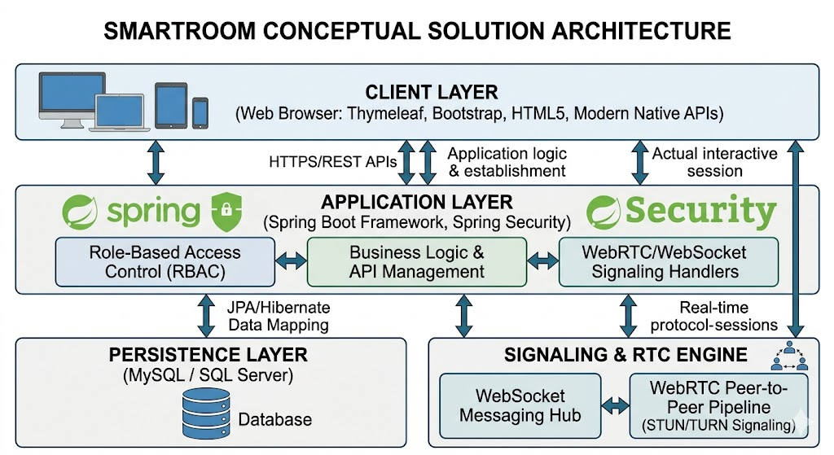
Fig 1.4. Solution architecture

1.5.2. Core Technological Interventions
The SmartRoom solution resolves the specific bottlenecks of legacy virtual platforms through three strategic technological implementations:
- Ultra-Low Latency via WebRTC: Instead of routing heavy video and audio streams through an expensive intermediary media server—which induces lag and requires high bandwidth—the solution establishes direct, secure peer-to-peer (P2P) multimedia connections between participants using WebRTC. This ensures the sub-500ms latency necessary for natural, interactive lectures.
- Full-Duplex Interactivity via WebSockets: To power the classroom chat, live participation lists, and instantaneous instructor permission revokations, the solution implements a persistent WebSocket connection. Unlike traditional HTTP polling, WebSockets allow the server to push real-time state changes to all connected student clients instantly with minimal packet overhead.
- Streamlined Classroom Security: The solution replaces vulnerable public links with an automated unique room-code generator. Combined with Spring Security filters, the platform validates every participant against the room state and role boundaries, equipping instructors with the absolute technical authority to control media streams, mute users, or terminate sessions smoothly.
By providing an integrated environment that balances lightweight accessibility with high security and real-time responsiveness, the SmartRoom architecture establishes a scalable framework tailored precisely for localized academic departments undergoing digital expansion.

CHAPTER 2. SYSTEM ANALYSIS AND DESIGN
Following the high-level system overview and requirement elicitation established in the initial chapter, this chapter shifts focus toward the rigorous technical decomposition, systematic analysis, and strategic architectural design of the SmartRoom platform. System analysis and design constitute a critical structural phase within the software development lifecycle, serving to translate abstract pedagogical and functional needs into concrete software engineering blue prints. By deeply examining user interactions, data transformations, and structural behaviors, this phase ensures that the resultant implementation is scalable, highly secure, and optimized for real-time performance.
The subsequent sections detail the analytical modeling of the system, beginning with a comprehensive requirements analysis that refines the system’s use cases and behavioral patterns. This is followed by the formal architectural and component design, database schema formulation, and interface abstractions. The structural blueprints detailed herein establish the definitive technical specifications required to guide the precise implementation of the Spring Boot backend, Spring Security boundaries, and real-time WebRTC/WebSocket communication channels in the later phases of the project.

2.1. Requirements analysis
Requirements analysis represents the foundational step in technical design, aimed at modeling, specifying, and validating the precise operational boundaries of the SmartRoom platform. The goal of this analysis is to transform raw functional expectations into highly structured, un-ambiguous technical constraints. Within an online classroom ecosystem, requirements analysis must effectively balance traditional web application data flows with the unique, state-dependent dynamics of real-time multi-user communication.
To achieve a comprehensive analytical model, the requirements analysis for SmartRoom is systematically executed through two distinct yet complementary engineering perspectives:

2.1.1. Actor and Role Differentiation
A precise understanding of system requirements necessitates the strict identification and isolation of the distinct actors interacting with the system. An actor represents any entity—human user or external system—that interfaces with the application boundaries to trigger specific workflows. In the SmartRoom platform, human actors are classified using a strict Role-Based Access Control hierarchy, ensuring that data exposure and operational capabilities are strictly confined to authorized parameters:
- The Instructor: This actor possesses elevated administrative privileges within the virtual classroom scope. The instructor initiates the room lifecycle, controls real-time participant permissions, alternates streaming configurations, and retains the authority to terminate sessions.
- The Student: This actor interacts primarily within a consumption and collaboration paradigm. Students access active rooms via randomized validation keys, participate in real-time text streams, and toggle their personal multimedia devices subject to the overarching permissions enforced by the instructor.
- The Administrator: An infrastructure-focused actor responsible for global platform maintenance, comprehensive user profile auditing, system log verification, and resource management, operating outside the active real-time classroom container.

2.1.2. Operational Flow and Behavioral Analysis
Beyond static role definitions, requirements analysis examines the dynamic behavioral patterns of the system under multi-user operational conditions. This involves analyzing the state transitions of the virtual classroom container—moving from an idle state, to active initialization, peer-to-peer signaling establishment, full-duplex messaging propagation, and ultimately, graceful session termination.
By analyzing these operational states, technical constraints such as concurrency handling, asynchronous thread management in the Spring Boot container, and real-time synchronization via the WebSocket messaging hub are formally specified. This deep behavioral analysis mitigates the risk of race conditions, unauthorized state alterations, and resource leaks during high-concurrency academic lectures, establishing a deterministic foundation for the subsequent structural design models.
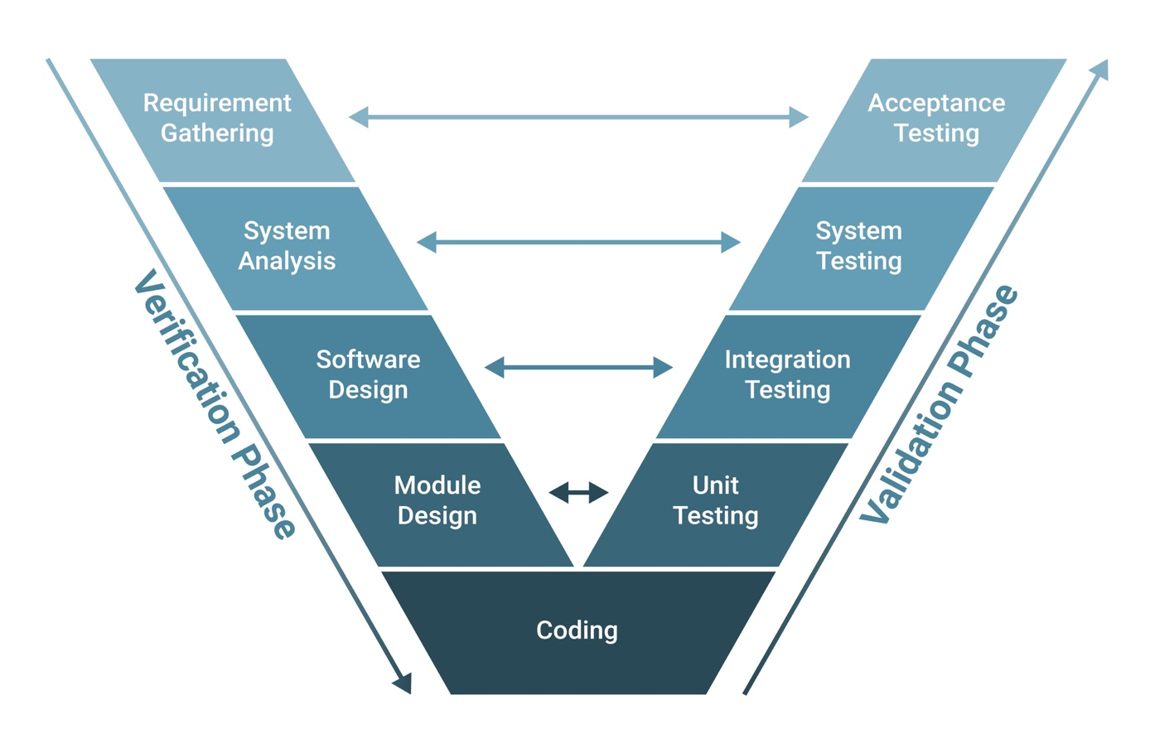
Fig 2.1. V-Model

2.2. Use case analysis
Use case analysis serves as a core behavioral modeling technique in object-oriented system design. By mapping the interactions between identified actors and the system boundaries, this analysis explicitly delineates "what" the system must accomplish from a user-centric perspective. For the SmartRoom platform, use case analysis bridges the gap between raw requirements and technical sequence validation, ensuring all business logic rules—such as role boundaries and state changes—are systematically accounted for.

2.2.1. System Use Case Diagram
The global functional capabilities of the SmartRoom platform are organized into modular use case packages. The instructor controls the lifecycle and state of the room, the student acts as an authenticated participant, and the administrator handles systemic overhead.
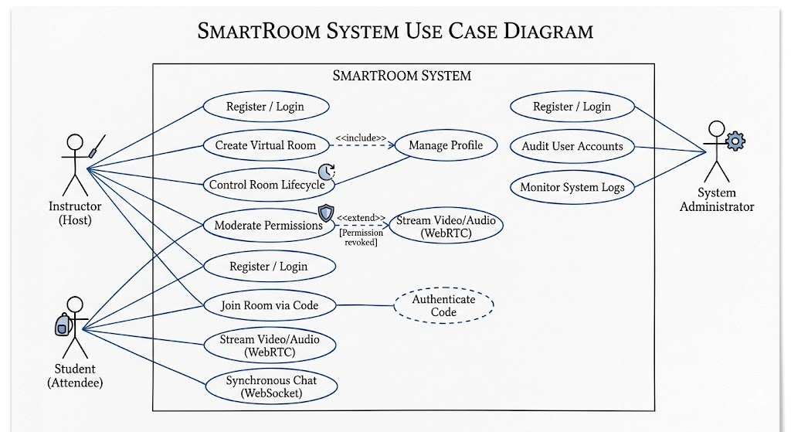
Fig 2.1. Use case diagram

2.2.2. Detailed Use Case Specifications
To ensure unambiguous implementation during the Spring Boot development phase, the core use cases governing room management and real-time streaming are formally specified below.
a. Use Case UC-01: Create Virtual Room
Actors: Instructor
- Description: Allows an authenticated instructor to initialize a new virtual classroom container with a secure, randomized access key.
- Pre-conditions: The Instructor must be successfully authenticated and logged into the system via Spring Security.
- Post-conditions: A new room record is persisted in the database; a unique room code is generated; the instructor is designated as the session host.
Main Success Scenario:
  - Instructor navigates to the management dashboard and clicks "Create New Room".
  - The system displays the room creation form demanding Room Name, Description, and Optional Schedule.
  - Instructor enters valid room details and submits the form.
  - The system validates the input, generates a unique, cryptographically secure 6-character alpha-numeric Room Code, and persists the room state as PENDING/INACTIVE in the database.
  - The system renders the room management view and displays the generated Room Code to the Instructor.
Alternative Flows:
Duplicate or Invalid Input: If the room name violates constraints, the system rejects the transaction, displays an inline validation error, and prompts the user to re-enter data.
b. Use Case UC-02: Join Room via Code
- Actors: Student
- Description: Enables a student to gain instantaneous entry into an active virtual classroom session by submitting a valid room identifier.
- Pre-conditions: The Student is logged into the web portal; the target room must currently be set to an ACTIVE state by the host.
- Post-conditions: The student client establishes a persistent WebSocket connection handshake with the room session.
Main Success Scenario:
  - Student clicks on "Join Room" from their dashboard interface.
  - The system prompts the student to input the unique Room Code.
  - Student enters the code and submits.
  - The system queries the database to verify code existence and checks if the room status is currently ACTIVE.
  - The system authorizes the session, maps the student's user ID to the active participant registry, and redirects the student browser to the live classroom interface.
Alternative Flows:
Invalid Room Code: If the code does not exist, the system alerts the user: "Room code not found."
Inactive Room: If the code is correct but the instructor has not activated the session, the system displays: "The classroom has not been opened yet."

c. Use Case UC-03: Moderate Participant Permissions
- Actors: Instructor
- Description: Dynamically alters the interaction rights (audio, video, text chat) of an active student inside the live session.
- Pre-conditions: Both the Instructor and the target Student must be active within the same real-time classroom container.
- Post-conditions: The student's media capabilities are altered via WebSocket state broadcasting without disrupting other peers.
Main Success Scenario:
  - Instructor views the live "Participant List" panel in the SmartRoom interface.
  - Instructor selects a specific student and clicks the "Mute Microphone" or "Revoke Video Permission" toggle.
  - The system processes the administrative request and dispatches a structural JSON payload via the established WebSocket channel to the target student's browser client.
  - The student's client-side browser intercepts the signaling packet, immediately invokes native track disablement on the local media stream, and updates the user UI to a muted state.
Alternative Flows:
Network Disconnection: If the target student drops offline before the packet delivers, the server cleans up the local cache, adjusts the active participant data array, and notifies the instructor that the user has left.

2.3. Database design
For data persistence, the project utilizes MySQL, a leading Relational Database Management System. MySQL is chosen for its reliability, strong data integrity, and excellent performance in handling structured data such as user profiles, classroom configurations, and session logs. Through Spring Data JPA and the Hibernate ORM, the system maps Java objects to database tables efficiently, ensuring seamless data synchronization and high availability for the "SmartRoom" platform.
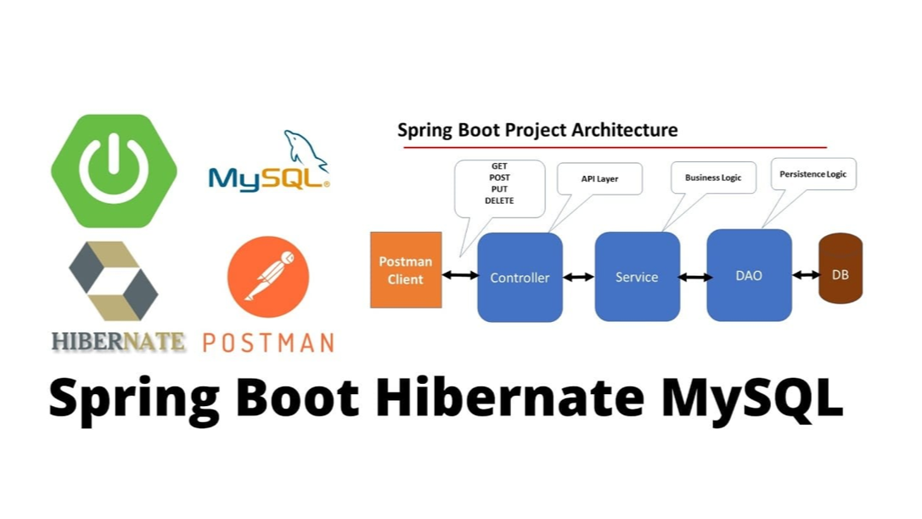
Fig 2.3. Data Management

2.3.1. Entity-Relationship Diagram Overview
The relational database architecture is split into two tightly coupled functional domains linked together via a unified user identity scheme:
Infrastructure & Reservation Domain: Manages physical rooms, assets, ad-hoc configurations, booking transactions, attendee schedules, and event-driven notifications.
Academic & Learning Management Domain (Extended): Manages specific educational profiles for instructors and students, classroom allocations, curriculum definitions, and standardized performance tracing (grades).

2.3.2. Data Dictionary
1. Table: users
Acts as the root registry for all accounts across the system ecosystem, establishing primary identity fields regardless of specific institutional roles.
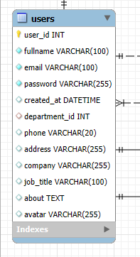
Fig 2.3.2.1. Users table
2. Table: roles
Defines the individual authority categories within the system to support Role-Based Access Control.
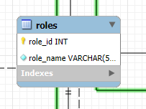
Fig 2.3.2.2. Roles table

3. Table: user_roles
A associative mapping table implementing a Many-to-Many relationship between users and functional access roles.
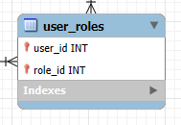
Fig 2.3.2.3. User_roles table
4. Table: departments
Stores academic divisions, branches, or organizational corporate departments.
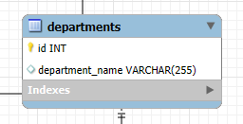
Fig 2.3.2.4. Departments table

5. Table: meeting_rooms
Maintains operational details regarding physical classrooms, virtual settings, or physical meeting structures.
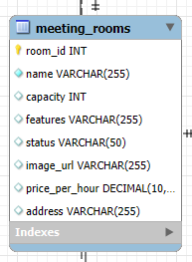
Fig 2.3.2.4. meeting_rooms table

6. Table: devices
Tracks standard structural inventory items and digital equipment that can be allocated across workspaces.
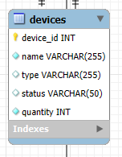
Fig 2.3.2.4. Devices table
7. Table: bookings
Handles atomic transactional scheduling entities for real-time online classes or synchronous presentations.
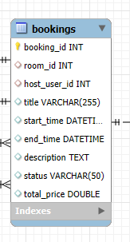
Fig 2.3.2.4. bookings table

8. Table: booking_attendees
Tracks the structural membership of specific users invited to explicit session events.
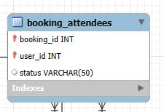
Fig 2.3.2.4. booking_attendees table

2.3.3. Key Integrity Constraints and Relational Rules
- Entity Integrity: Distinct primary keys are strictly enforced on every system entity. Column auto-incrementation strategies minimize application layer generation bottlenecks while preventing duplicate entry overlaps.
- Referential Integrity: Implemented on sub-profile definitions. If a core record inside the master users registry gets truncated, all matching academic records are deleted automatically, maintaining database cleanliness.

2.4. System architecture design
The overall architecture of the Smartmeeting system is designed based on a modern multi-tiered architecture pattern. This design pattern ensures a strict Separation of Concerns among components, enhances system security, optimizes multi-threaded concurrent processing performance, and facilitates seamless future maintainability and scalability.

2.4.1. Multi-tiered Architecture Overview
The system is structurally organized into three core functional layers and an independent low-latency real-time communication channel:
1. Presentation Layer
- Technologies Used: Thymeleaf Templating Engine, HTML5, CSS3, JavaScript, and the Bootstrap Framework.
- Role and Responsibility: This layer serves as the graphical user interface GUI interacting directly with end-users. It delivers a highly fluid and responsive web interface that renders cross-platform layouts on both desktops and mobile web browsers without demanding any native application setup. Pages are rendered dynamically server-side via Thymeleaf or updated asynchronously using asynchronous client-side API fetches.
2. Business Logic Layer
- Technologies Used: Spring Boot Framework, Spring Security.
- Role and Responsibility: Operating as the central nervous system of the software, this layer intercepts, computes, and dispatches all core workflow operational demands:
- Security Filter Chain: Implements an explicit authentication and authorization firewall utilizing Role-Based Access Control. It guarantees strict operational encapsulation—ensuring students can only view their individual academic records, teachers maintain exclusive permissions to evaluate classrooms and adjust grades, and corporate handlers manage infrastructure properties.
- Controllers & Services Modules: Processes incoming incoming HTTP controllers and routes. It executes logical behaviors e.g., assessing asset constraints, evaluating room allocation collisions, managing class enrollments, and recording grades before mapping responses back to the frontend presentation layout.
3. Data Persistence Layer Database Server
- Technologies Used: MySQL RDBMS, Spring Data JPA.
- Role and Responsibility: Ensures long-term transactional safety and physical data consistency. Spring Data JPA serves as an Object-Relational Mapping abstract mediator, converting programmatic Java Entity models directly down to MySQL relational relational structures. This avoids manual SQL tracking and optimizes performance using connection pooling and transaction managers.

2.4.2. Real-time Communication Architecture
To meet the fundamental standards required by a highly collaborative online training space, the system runs dual asynchronous real-time protocol engines concurrently:
1. Peer-to-Peer Video/Audio Pipeline WebRTC
- Role and Responsibility: Provides low-latency, high-definition video conferencing and voice streams directly between participants during active digital sessions.
- Architectural Flow: Because WebRTC relies heavily on peer-to-peer P2P connections to exchange intensive media traffic directly between browsers (saving expensive server-side video transcoding bandwidth, the central Spring Boot instance acts as the designated Signaling Server. Browsers use this signaling connection to exchange configuration criteria ICE Candidates and media stream protocols before establishing their direct P2P connection channels.
2. Bidirectional Messaging & Event Broadcaster
- Role and Responsibility: Powers the instant chat features inside running classrooms and provides immediate user alerts without forcing manual web page reloads.
- Architectural Flow: Opens a persistent full-duplex communication pipeline between the browser environment and the Spring Boot application instance. When an instructor sends a live message or the backend modifies a scheduling transaction, data is propagated across this open WebSocket channel instantly to intended destinations with minimal networking overhead.

2.4.3. Architectural Quality Attributes
The architectural baseline of the Smartmeeting system satisfies several critical software quality attributes:
- Security: Isolating the physical database infrastructure completely behind the Spring Security framework prevents direct external queries, limits exposure to injection vectors e.g., SQL Injection via JPA parametrizations, and blocks unauthorised route executions.
- Performance & Scalability: Offloading massive multi-user live audio/video payloads directly via WebRTC peer networks preserves backend hardware power. Furthermore, the non-blocking execution pattern of WebSockets ensures the Spring Boot engine can manage many simultaneous online learning rooms without running into centralized resource starvation.
- Maintainability & Extensibility: Adhering to strict modularity and layered design isolates changes to specific components. For instance, developing and introducing the new Academic Management Module to handle student and teacher profiles, classroom assignments, and grade books has no structural effect on the stability of the preexisting infrastructure booking engine.
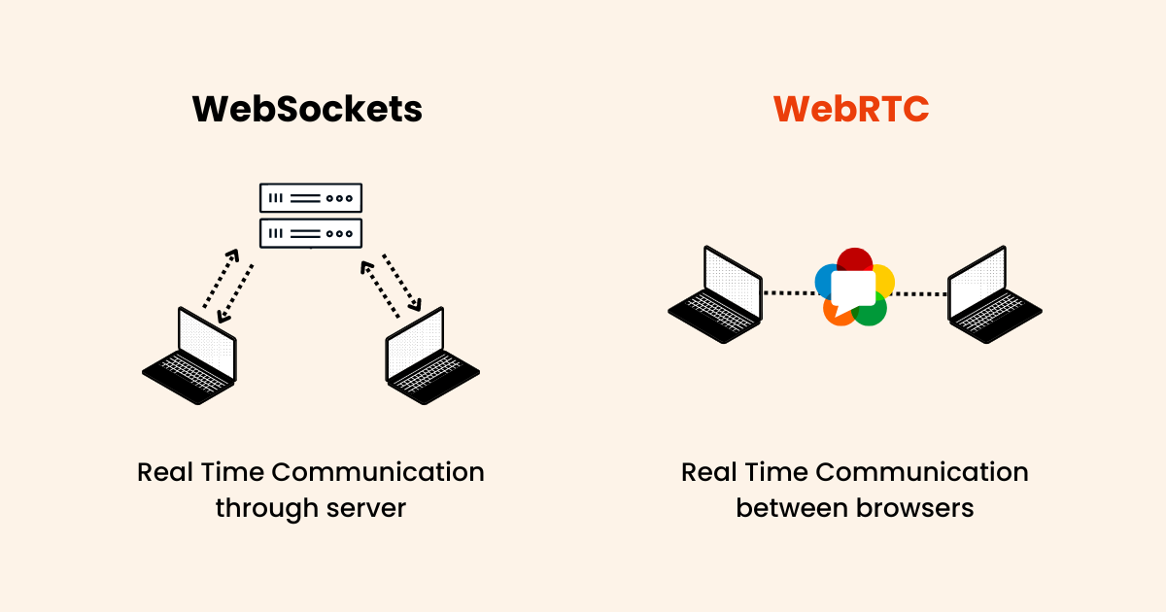
Fig 2.4. Real-Time Communication

2.5. User interface design
The User Interface and User Experience design of the “SmartRoom” platform are engineered based on the core principles of simplicity, clarity, efficiency, and full accessibility. Given that the presentation layer relies on Thymeleaf templates coupled with the Bootstrap framework, the system guarantees an entirely responsive behavior across varied device forms, adapting layouts smoothly from wide-screen desktop displays to mobile touchscreens without omitting operational components.

2.5.1. Core Design Guidelines and Principles
- Consistency: The visual language utilizes a uniform component vocabulary across all modules. Standard elements—such as datatables for listings, modal windows for confirmations, and consistent color semantics for indicators—ensure that users do not need to re-learn controls as they transition between room reservations and academic grade tracking.
- Role-Based Adaptive Layouts: Leveraged through Spring Security-driven server-side rendering within Thymeleaf, the interface automatically mutates according to the logged-in user's active authority group “ROLE_ADMIN, ROLE_TEACHER, or ROLE_STUDENT”. Actions that are unauthorized are completely hidden from the view layer, reducing interface clutter and preventing user mistakes.
- Color Psychology & Accessibility: The interface layout relies on an industrial blue-and-gray semantic color palette to minimize eye strain during extended classroom sessions. Dynamic badge notifications utilize standard color alerts: Green for successful operations “ACTIVE, CONFIRMED, APPROVED”, Yellow for pending or system state changes “MAINTENANCE, PENDING”, and Red for severe alerts or dropped sessions “CANCELLED, OVERDUE”.
- Responsive Grid System: By adhering to Bootstrap’s 12-column fluid grid mechanism, the visual elements collapse into nested mobile configurations. Sidebars collapse into slide-out drawers on smaller screens, and complex tabular structures utilize horizontal scroll enclosures to maintain absolute numerical visibility.

2.5.2. Functional Dashboard and Layout Breakdowns
The application is split into four primary interface zones to serve distinct system entities:
1. Global Viewport Shell
Every logged-in view shares a consistent layout shell containing:
- A Sticky Top Navigation Bar: Features the organizational logo, global search bar, an ad-hoc quick-booking button, and an animated WebSocket-powered notification bell dropdown icon that updates in real-time when room approvals or session alerts are dispatched.
- An Elastic Sidebar Menu: Provides access routes corresponding to active roles. Clicking sidebar options uses responsive active-state indicators to orient users within the system hierarchy.
2. Student Academic Portal
Tailored for ROLE_STUDENT to provide seamless tracking of interactive learning activities and performance:
- Virtual Classroom Interface: A dual-column unified view configured for online lectures. The wide column hosts the low-latency WebRTC HTML5 video container, complete with custom video toggle controls. The right column integrates the persistent WebSocket synchronous text-chat room panel for live session questions and collaborative note-taking.
- Grade Analytics Board: A clean grid of cards categorized by subject. Clicking a subject card opens a detailed tab listing historical grade parameters fetched and calculated dynamically from the academic_records table, complemented by automated progress summaries.

3. Teacher Management Desk
Optimized for ROLE_TEACHER to minimize administrative overhead and maximize classroom orchestration:
- Class Cohort Registry: Displays an exhaustive data grid of classes and students assigned to the instructor. Teachers can seamlessly review parental contact data and attendance trends in one view.
- Evaluation Grid: An interactive matrix worksheet matching student records against evaluation types. Input boxes feature client-side JavaScript formatting boundaries (restricting values between 0.00 and 10.00). Modifications dynamically enable a "Save Changes" state to prevent accidental loss of grades.
4. Infrastructure & Administrative Control Center
Designed for ROLE_ADMIN to manage hardware distribution and handle facility scheduling:
- Interactive Reservation Timeline: Uses a calendar grid layout mapping hours against physical rooms. Clicking an empty slot opens a pre-populated room modal, while booked slots display informative tooltips detailing the host's department, current utility load, and allocated equipment.
- Asset Allocation Screen: A master tracking dashboard splitting hardware assets between main warehouses and fixed room configurations. Warning indicators flash automatically if additional requested devices exceed the current global safety thresholds.

2.5.3. User Interface Navigation Flow and Screen Transitions
The system utilizes an optimized state machine model for user movement between screens, eliminating unnecessary full-page refreshes through programmatic modal confirmations and async form submissions:
- Authentication Step: Users start at a centralized login interface. Failed authorization input displays immediate Bootstrap form validation alerts without clearing the page context, adhering to Spring Security exception specifications.
- Dashboard Landing: Successful authentication forwards the client browser to the targeted user type homepage dashboard.
- Active Session Invitation: If an online lecture or conference room slot becomes active, an animated banner alert slides into view across the top navigation bar. Clicking this interactive link switches the user directly to the target WebRTC Live View screen layout with one click.
- Asynchronous Actions: Actions such as processing asset allocations or modifying student grade registers take place within dynamic Bootstrap modal dialog overlays. When these tasks are saved, the target content container updates asynchronously, providing a fast and polished software experience.
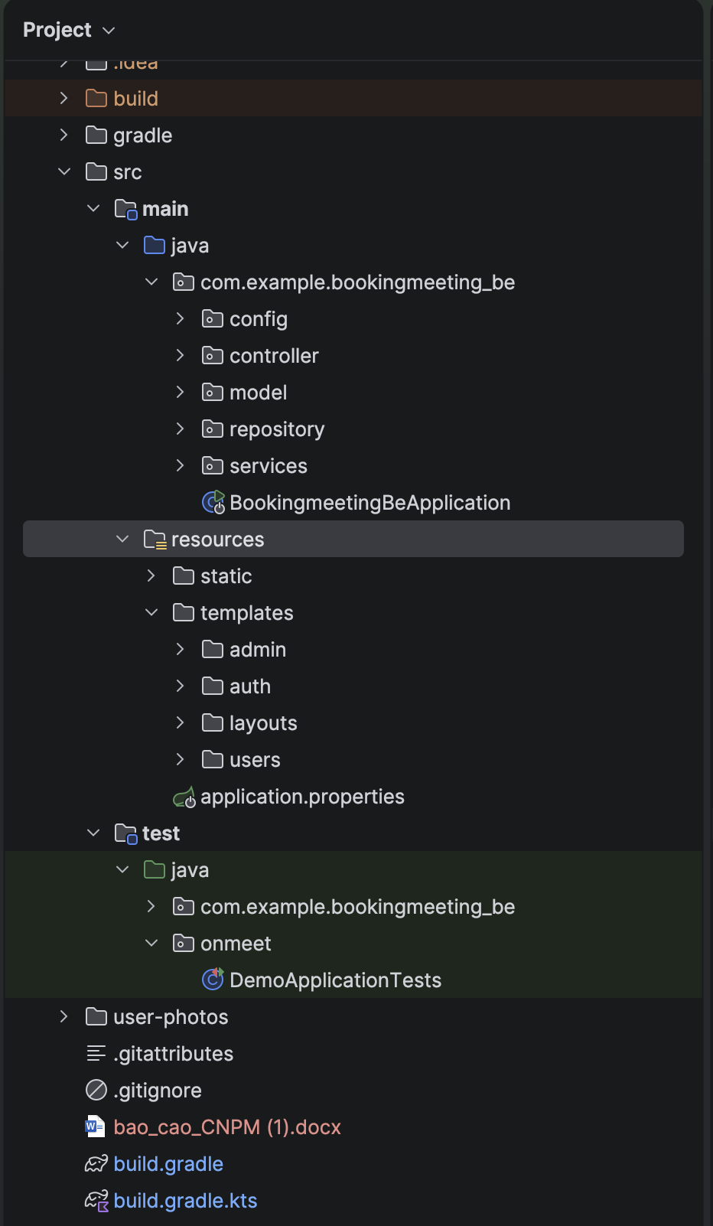
Fig 2.5. Project Directory Structure and Organization

CHAPTER 3. SYSTEM IMPLEMENTATION AND EVALUATION

3.1. Development environment and technologies
The implementation phase transforms the theoretical design described in Chapter 2 into a fully functional software product. To ensure high performance, scalability, and cross-platform compatibility, the Develop an Online Classroom Management System utilizes a modern technology stack consisting of Java, Spring Boot, MySQL, and Artificial Intelligence technologies.
The development environment was configured to support collaborative software engineering practices among the project members. The technologies were selected based on performance efficiency, scalability, community support, and compatibility with website development.

3.1.1. Java Programming Language
Java is the primary programming language used to develop the backend system of the Online Classroom Management System. Java was selected because of its stability, platform independence, high performance, and strong support for enterprise application development. With the “write once, run anywhere” capability provided by the Java Virtual Machine, the system can operate consistently across different environments and server platforms.
Java also provides a large ecosystem of libraries and frameworks that simplify the development process. In this project, Java works together with the Spring Boot framework to build Thymeleaf APIs, manage business logic, handle authentication, and process data efficiently. These features are important because the application includes user management, online classroom operations, assignment handling, attendance tracking, and real-time data processing.
Another advantage of Java is its strong security mechanisms and scalability. This ensures that the system can securely manage large numbers of users, maintain stable performance under heavy workloads, and support future expansion of the application.

Fig 3.1. Java Programming Language

3.1.2. Spring Boot Framework
Spring Boot is the primary backend framework used to develop the Online Classroom Management System. Spring Boot was selected because it simplifies the development of enterprise-level Java applications by providing built-in configurations, dependency management, and rapid application setup. This allows developers to focus more on implementing business logic rather than configuring the system manually.
Spring Boot also supports the development of Thymeleaf APIs, database integration, authentication, and security features efficiently. In this project, Spring Boot is used to manage user accounts, classroom operations, assignment processing, attendance tracking, and communication between the frontend and the database.

Another advantage of Spring Boot is its scalability and compatibility with the Spring ecosystem. It integrates easily with technologies such as Hibernate, RESTful, MySQL, and Spring Security, helping the system maintain high performance, modular architecture, and easy maintainability. Furthermore, Spring Boot supports microservice architecture and cloud deployment, making the application easier to expand and deploy in the future.

Fig 3.2. Spring boot Framework

3.1.3. MySQL Database
MySQL is the primary relational database management system used in the Online Classroom Management System. MySQL was selected because of its reliability, high performance, scalability, and strong compatibility with Java and Spring Boot applications. It provides efficient data storage and management capabilities for handling large amounts of academic and user-related information.
In this project, MySQL is used to store and manage important system data such as user accounts, classroom information, attendance records, assignments, grades, and learning progress. Its relational database structure helps maintain data consistency, integrity, and efficient querying operations.
Another advantage of MySQL is its strong community support and security features. It supports transaction management, backup and recovery mechanisms, user authentication, and access control, ensuring that sensitive educational data is stored securely. Furthermore, MySQL integrates smoothly with backend technologies such as Spring Boot and Hibernate, making database operations more efficient and easier to maintain.
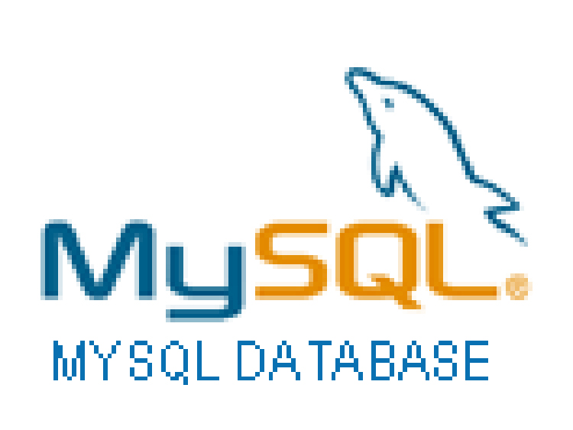
Fig 3.3. MySQL Database

3.1.4. Artificial Intelligence Technologies
Artificial Intelligence technologies are integrated into the Online Classroom Management System to enhance learning efficiency, automate educational processes, and provide intelligent support for both students and lecturers. AI was selected because it enables the system to analyze data, generate insights, and improve user interaction through intelligent features.
In this project, AI technologies are used for functions such as automated attendance recognition, learning progress analysis, intelligent recommendations, and educational assistance. These features help lecturers monitor student performance more effectively while allowing students to receive personalized learning support and feedback.

3.2. System implementation

3.2.1. Login Page Interface
The Login Page Interface allows users to securely access the Online Classroom Management System by entering their username and password. This interface is designed with a simple, user-friendly layout to ensure easy navigation and efficient authentication for both students and lecturers. Additionally, the login page integrates validation and security mechanisms to protect user accounts and maintain system security.
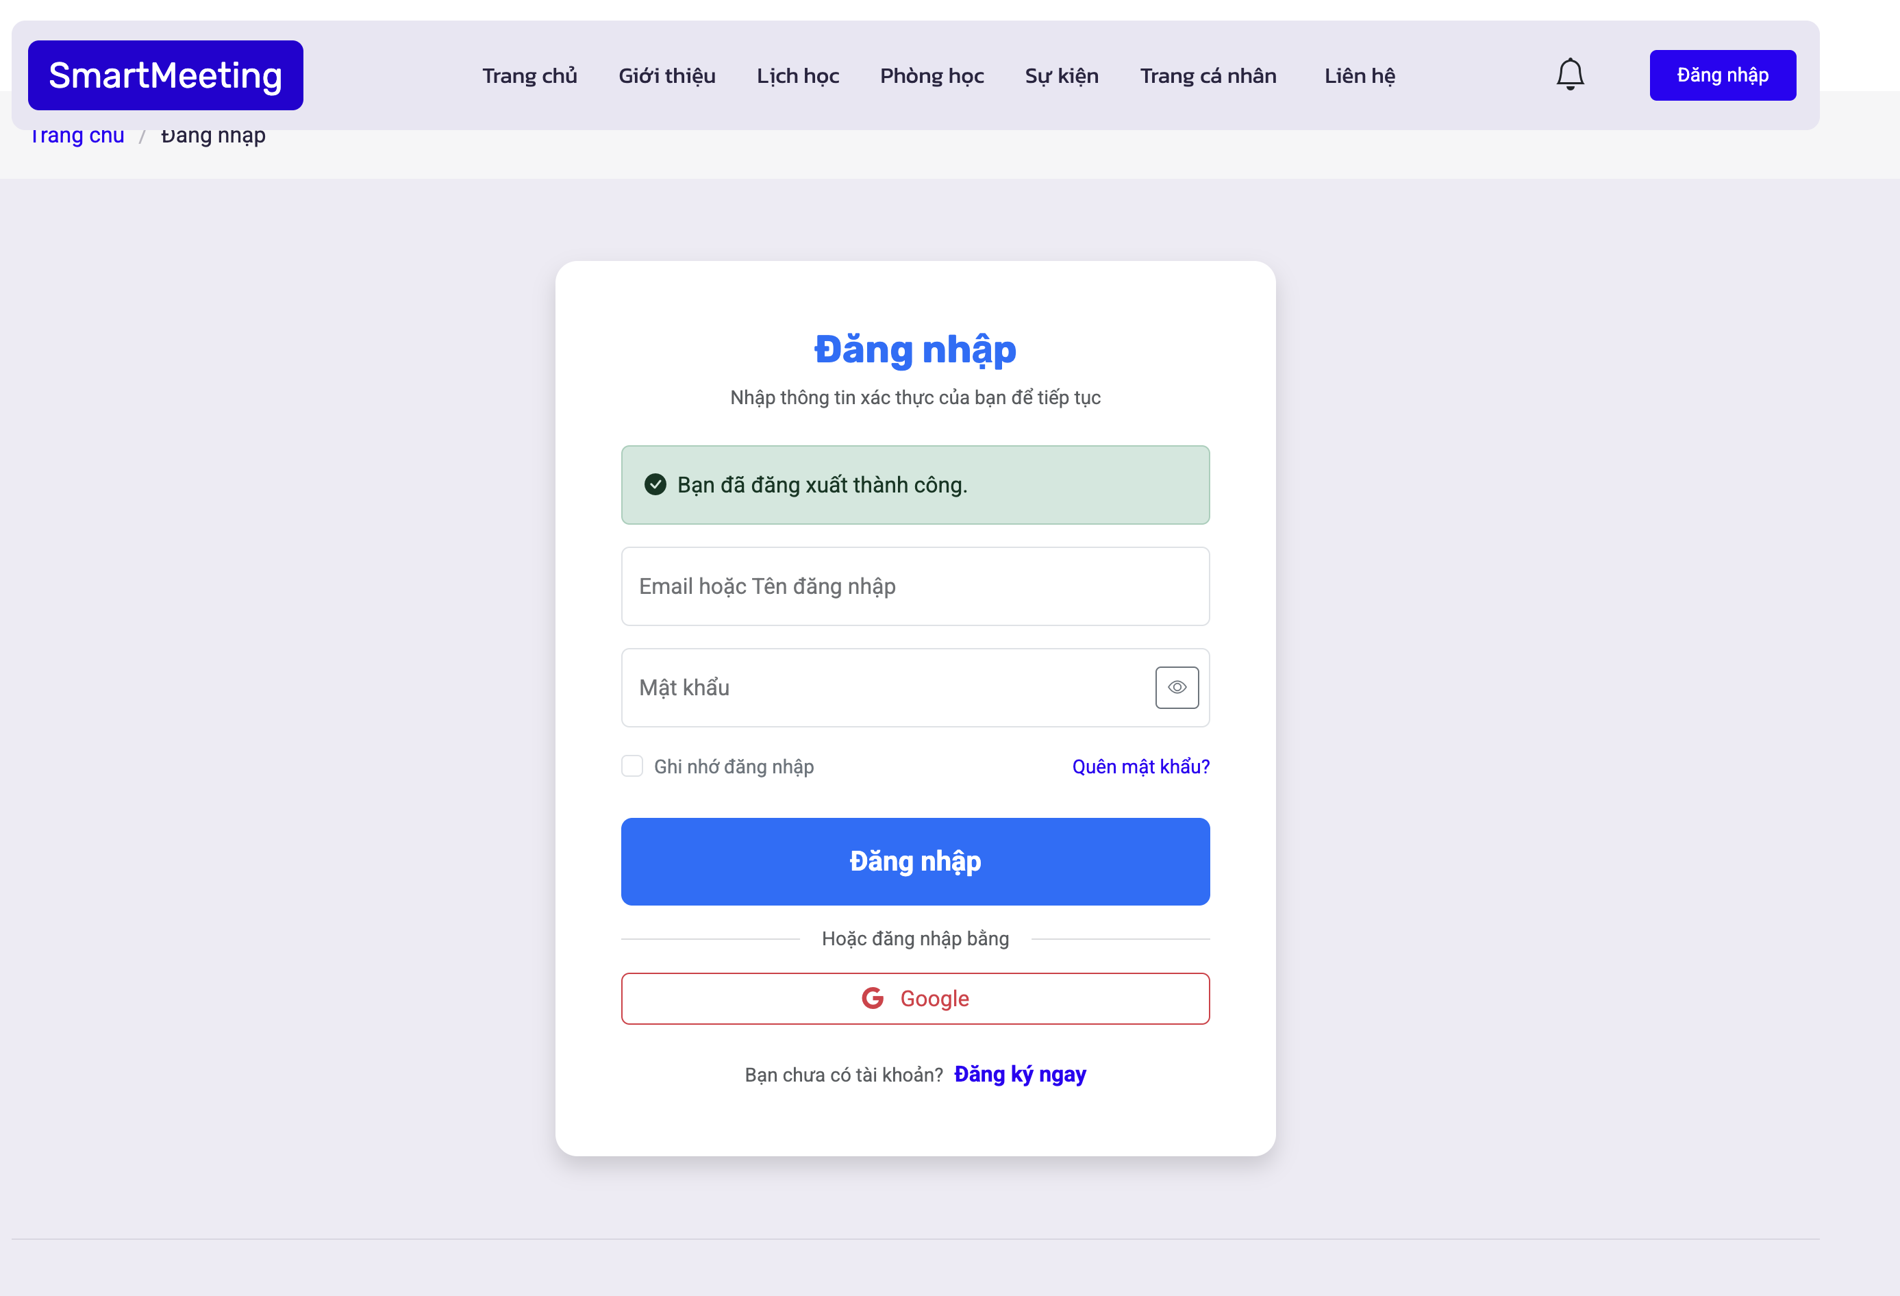
Fig 3.4. Login Page Interface

3.2.2. Registration Page Interface
The Registration Page Interface allows new users to create an account in the Online Classroom Management System by providing personal and academic information such as username, email, password, and role selection. The interface is designed to be simple, intuitive, and user-friendly, helping users complete the registration process quickly and accurately.
Additionally, the registration page includes input validation and security mechanisms to ensure data accuracy and protect user information. These features help prevent invalid registrations, improve system reliability, and provide a secure account creation process for students and lecturers.
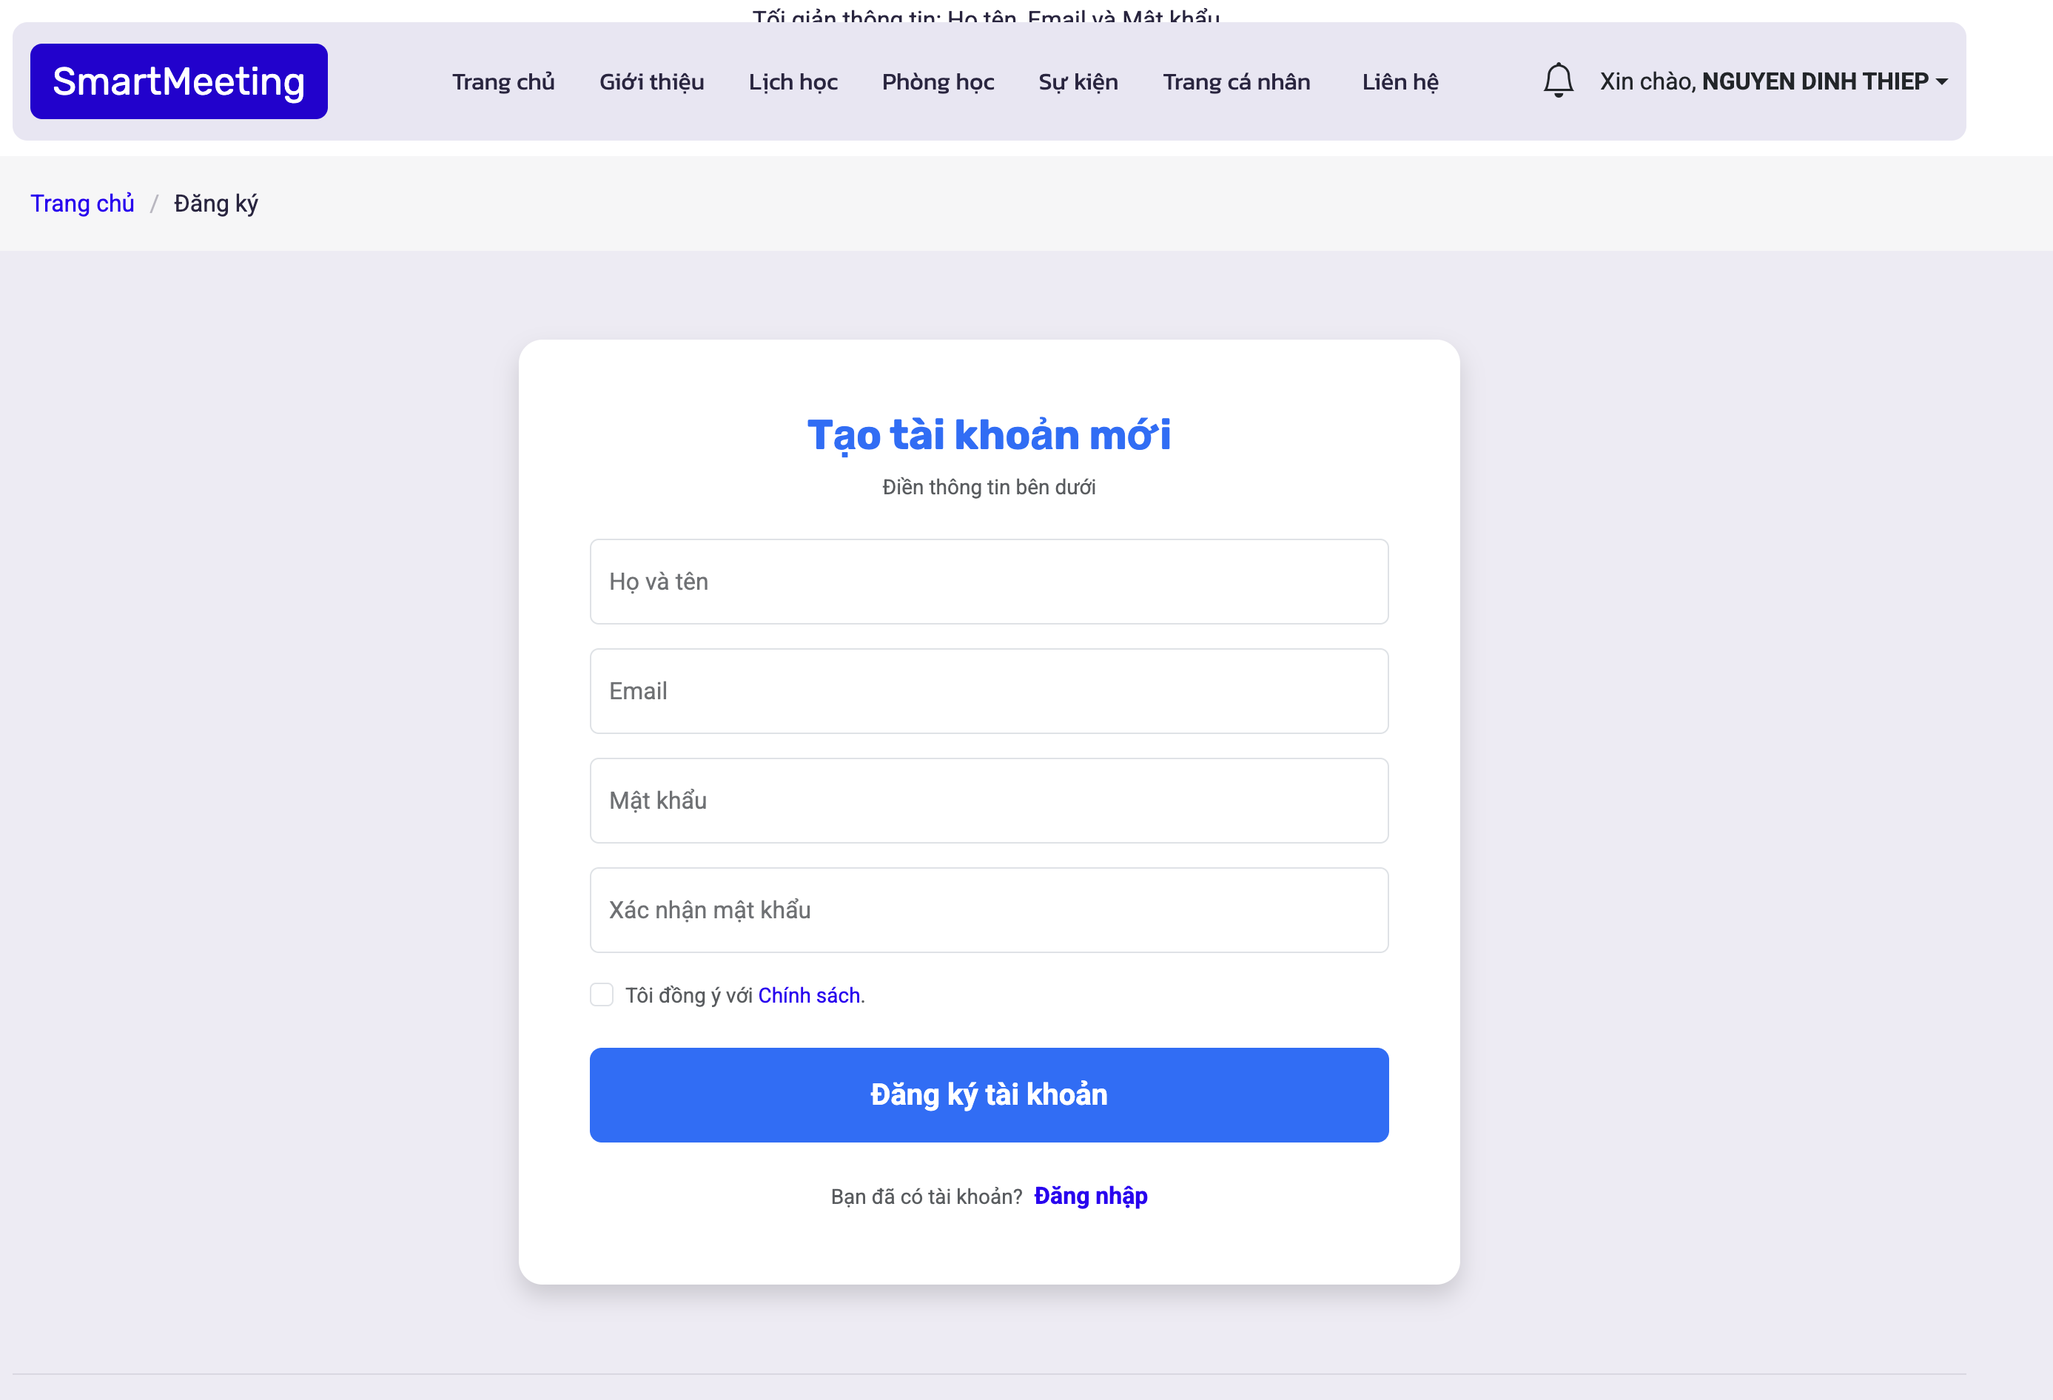
Fig 3.5. Registration Page Interface

3.2.3. Home Page Interface
The Home Page Interface serves as the central dashboard of the Smartmeeting Room Management System. It provides users with quick access to important features such as meeting schedules, meeting room management, event organization, and personal account management. The interface is designed with a modern and professional layout to enhance usability and improve user experience.
The homepage also displays key information and system highlights, including 24/7 operation support, nationwide service availability, and online broadcasting features. In addition, interactive buttons such as “Register Now” and “Create Meeting” allow users to quickly perform essential actions within the system. The responsive design ensures compatibility across different devices and screen sizes.
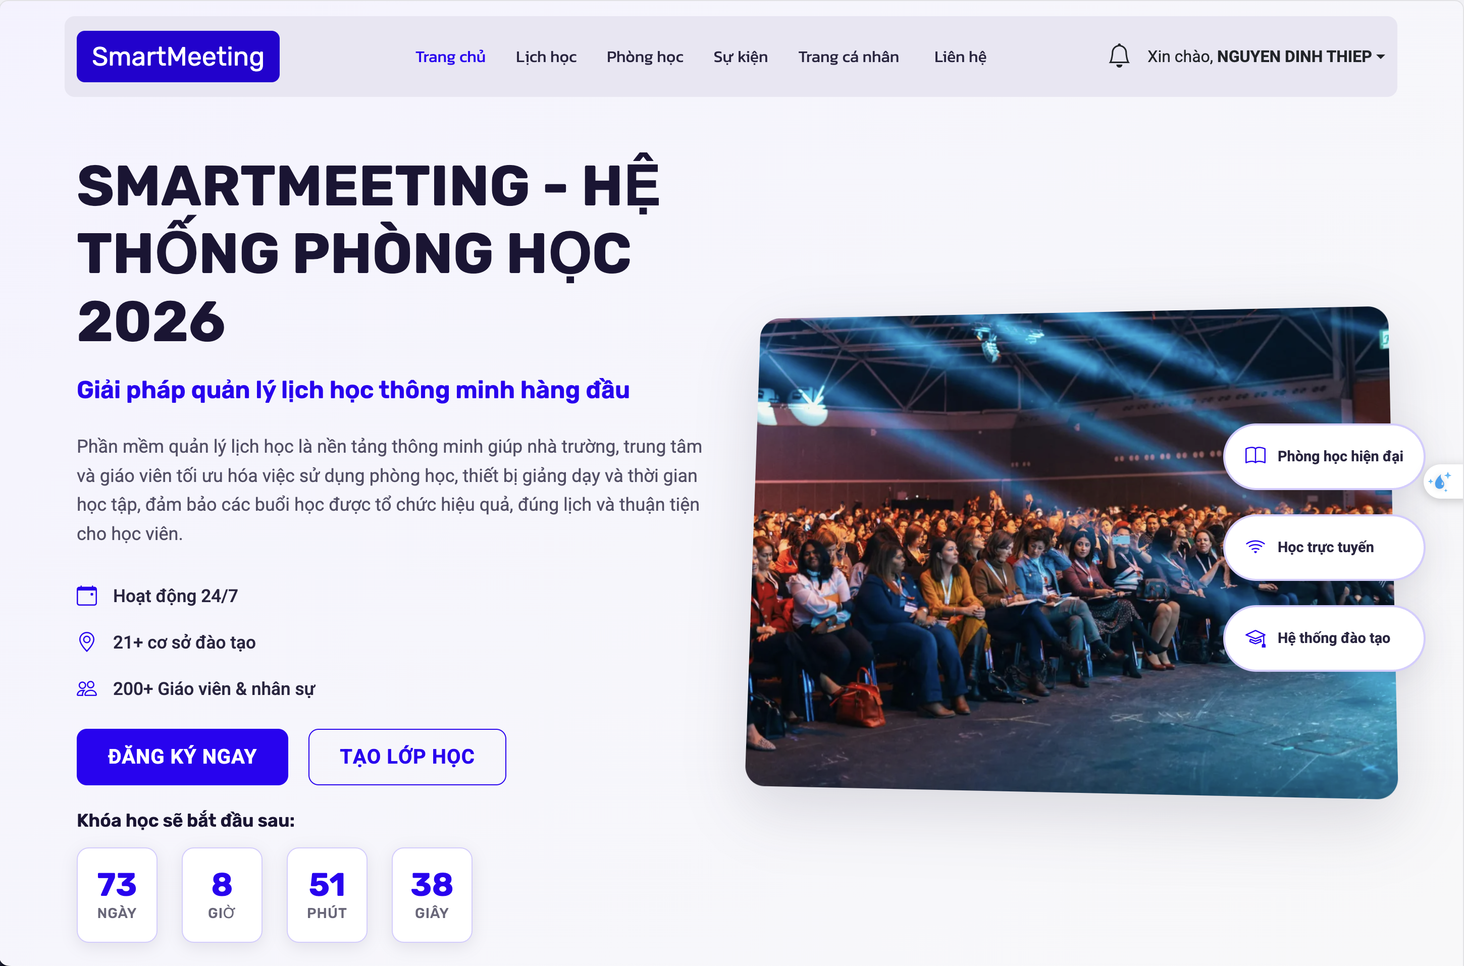
Fig 3.6. Home Page Interface

3.2.4. Introduction Page Interface
The Introduction Page Interface provides an overview of the Smartmeeting Room Management System, including its objectives, core functionalities, and benefits for organizations and businesses. This page introduces the system as an intelligent meeting scheduling and management platform designed to reduce scheduling conflicts, optimize resource usage, and improve operational efficiency.
The interface presents information using a modern and visually appealing layout combined with images, statistics, and highlighted features. Key indicators such as the number of offices, conference halls, departments, and customers are displayed to enhance credibility and demonstrate the scale of the system. Additionally, the responsive design ensures smooth accessibility across different devices and platforms.
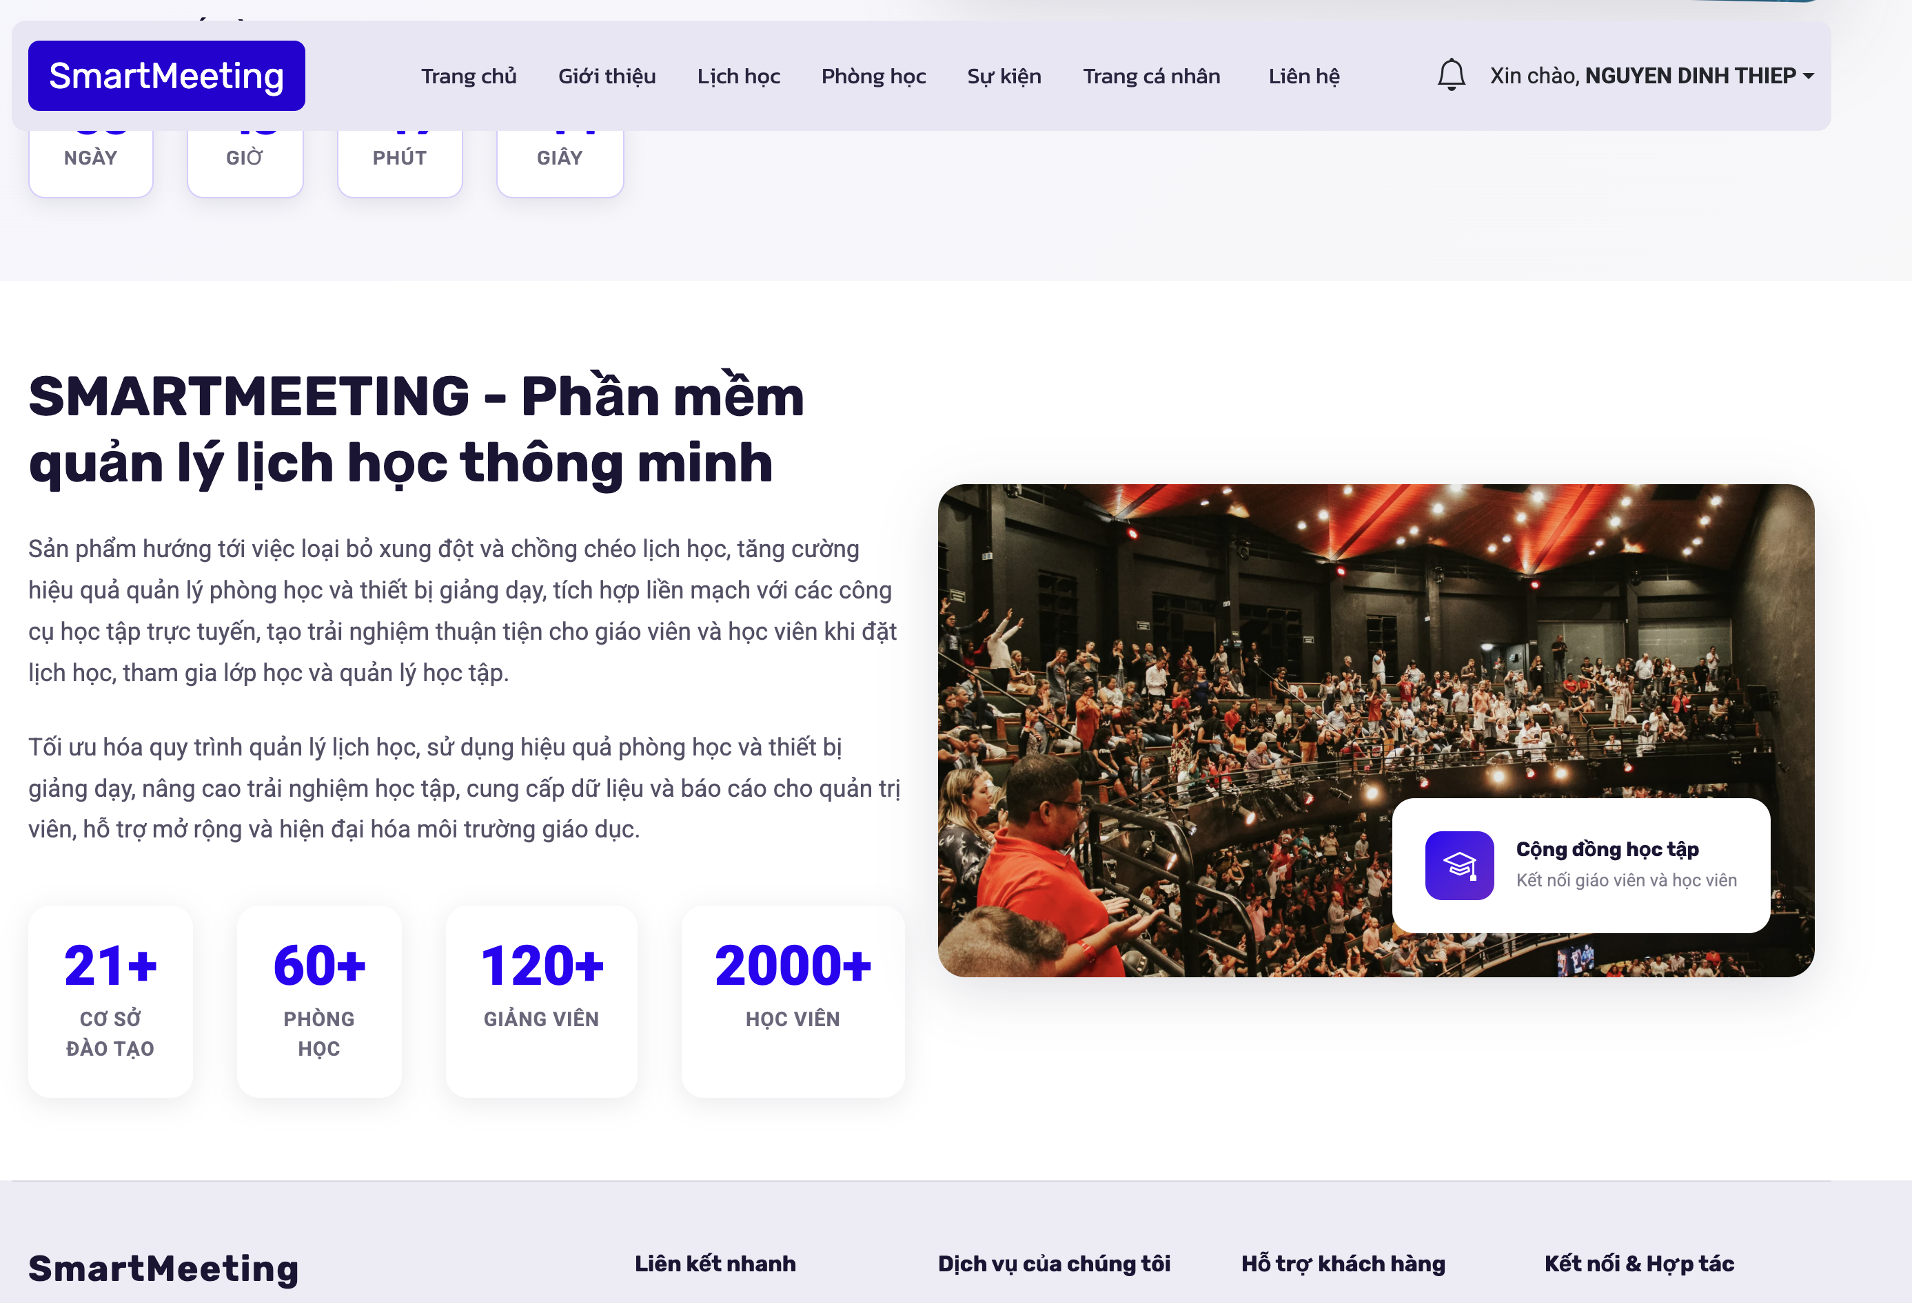
Fig 3.7. Introduction Page Interface

3.2.5. Admin Page Interface
The Admin Dashboard Interface serves as the central management panel of the Smartmeeting Room Management System. This interface allows administrators to monitor system activities, manage users, control meeting rooms and devices, and oversee meeting schedules efficiently. The dashboard is designed with a clean and modern layout to provide easy navigation and quick access to important management functions.
The left sidebar contains the main navigation menu, including user management, device management, meeting room management, meeting schedule management, operation center, and personal profile management. The top navigation bar provides search functionality, notification access, and administrator account information, improving usability and system interaction.
Additionally, the dashboard displays statistical cards and analytical information such as today’s meeting schedules, monthly meetings, participant activities, recent system activities, and system notifications. Visual components such as charts and activity summaries help administrators monitor system performance and make management decisions more effectively. The responsive design also ensures compatibility across multiple devices and screen sizes.
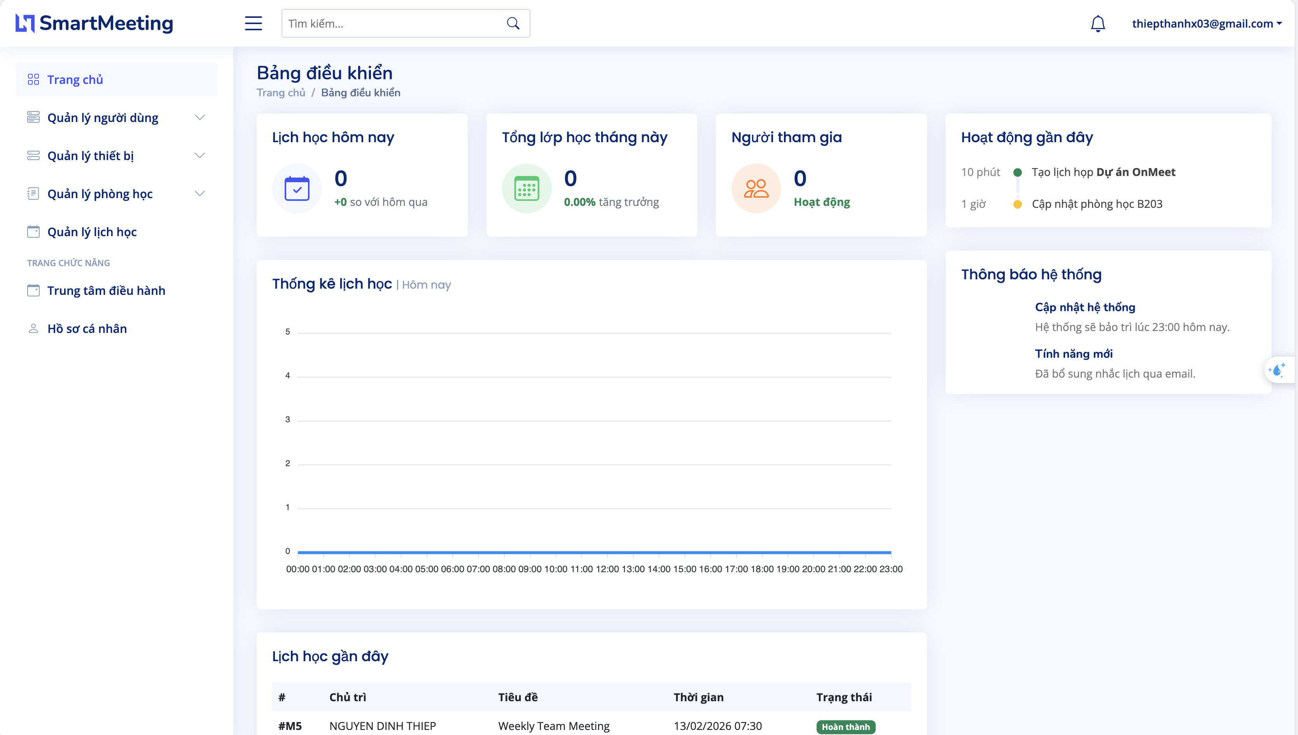
Fig 3.8. Admin Interface

3.3. Main functional modules
This section details the primary functional modules of the Smartmeeting system, as illustrated in the implemented user interfaces.

3.3.1. Meeting Schedule & Timeline Module
This module provides a chronological view of all scheduled sessions. It allows users to filter meetings by specific dates. Each entry displays the timeframe, session title, speaker information, and a direct "Join" button, ensuring seamless navigation for participants.
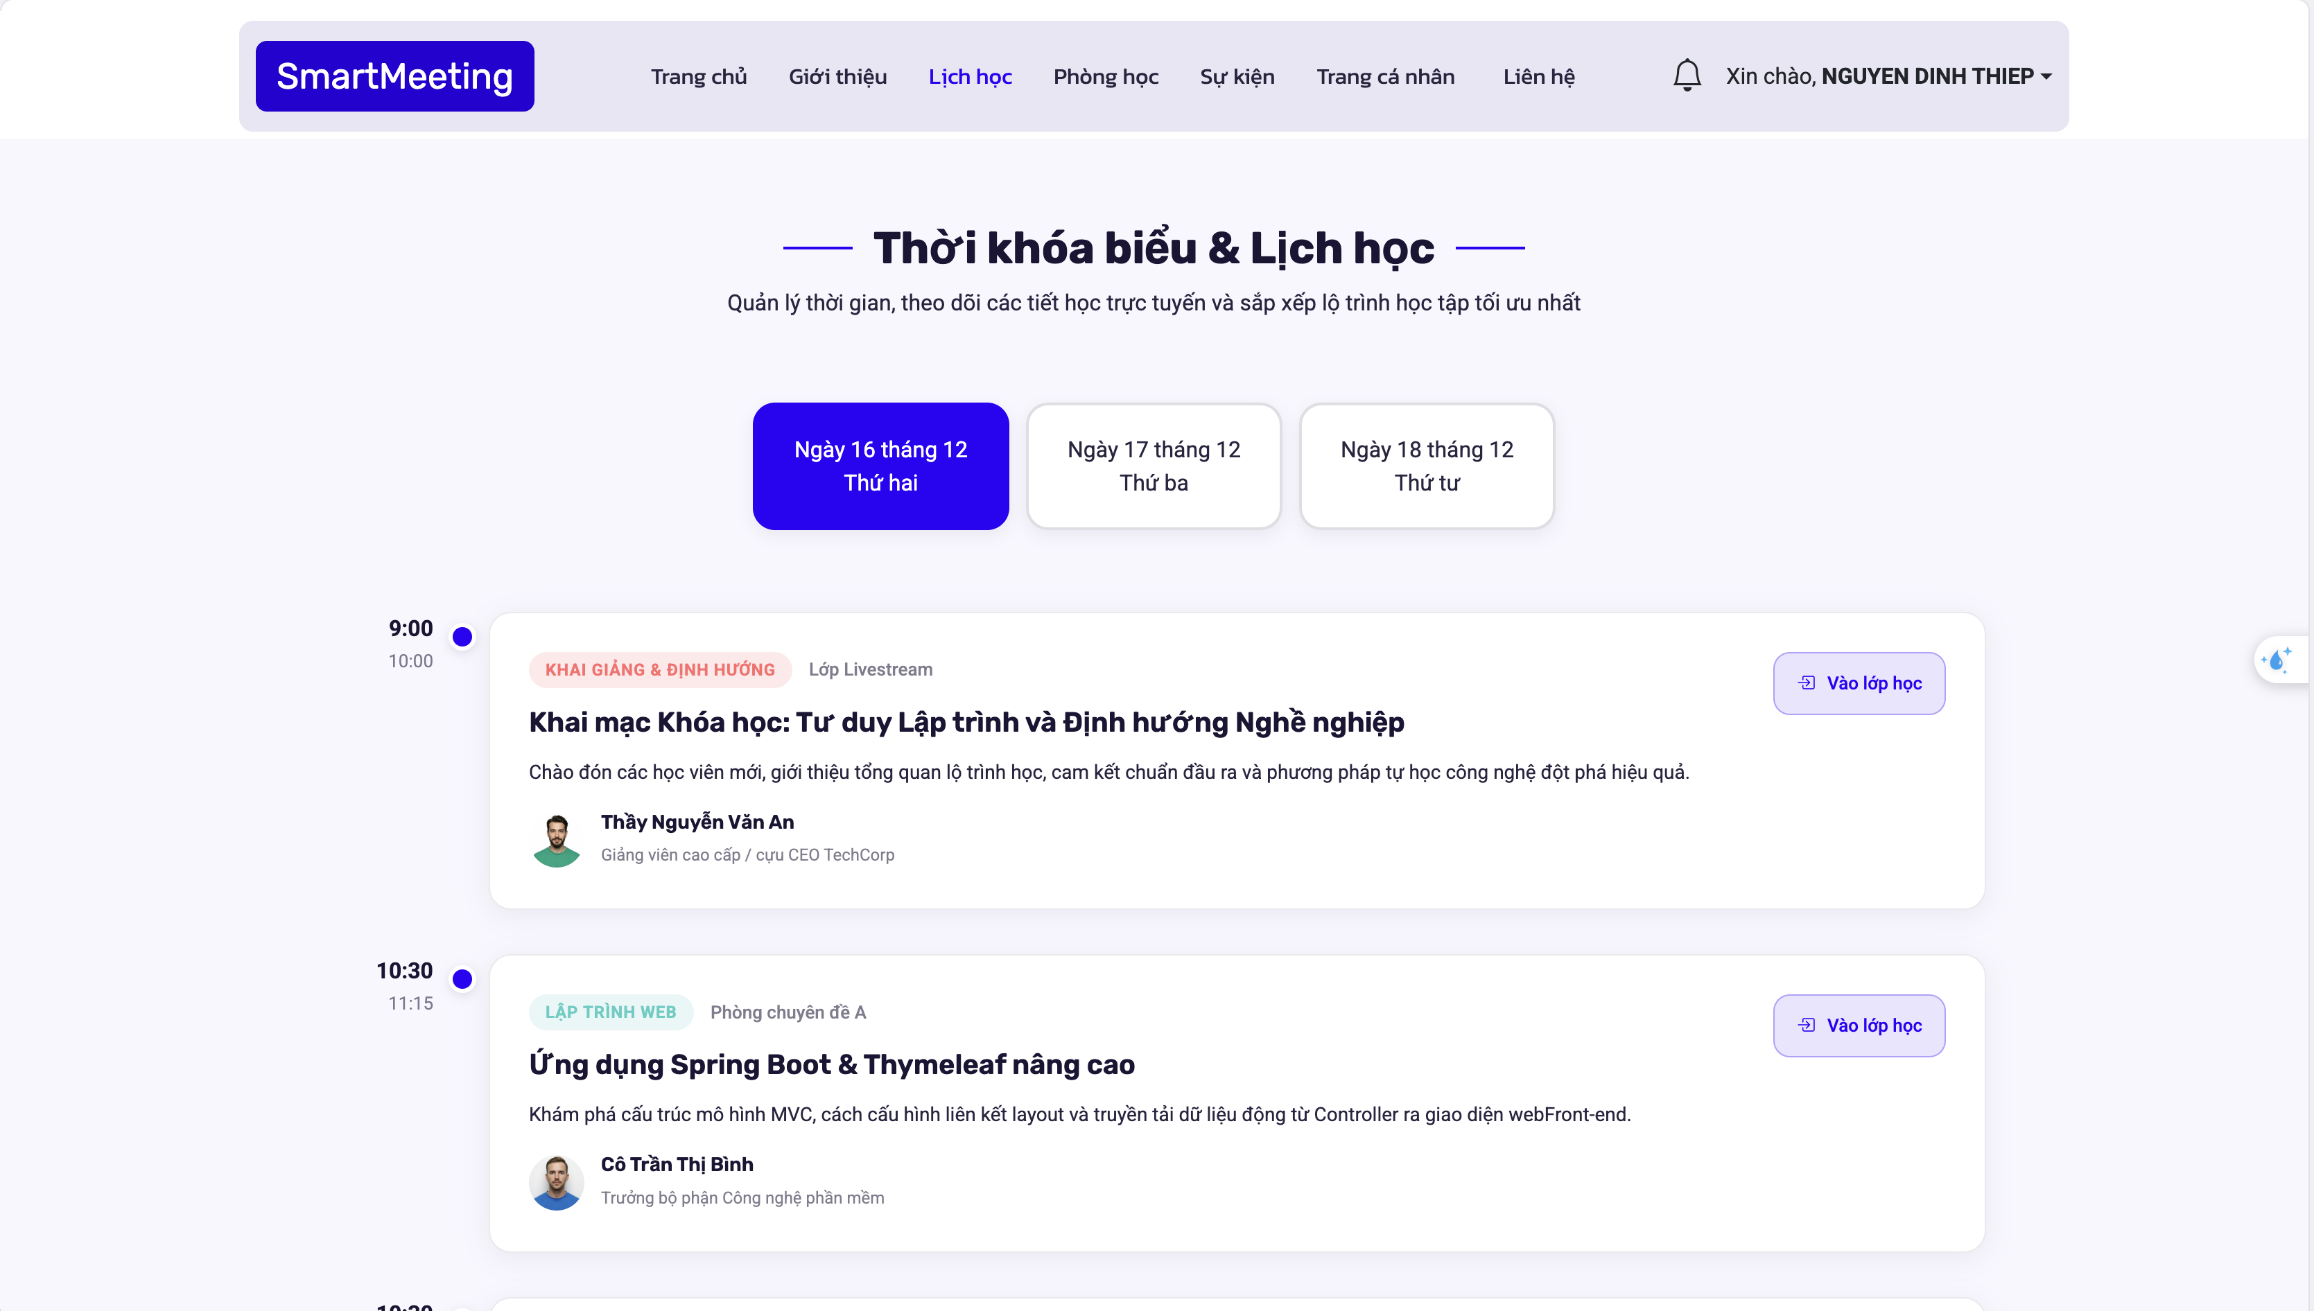
Fig 3.9. Meeting schedule page interface

3.3.2. Meeting Room Management Module
This module handles the availability and technical specifications of physical and virtual spaces. It categorizes rooms by status “ACTIVE” for ready rooms and MAINTENANCE for those under repair. It also tracks capacity, location details and amenities such as projectors or refreshments.

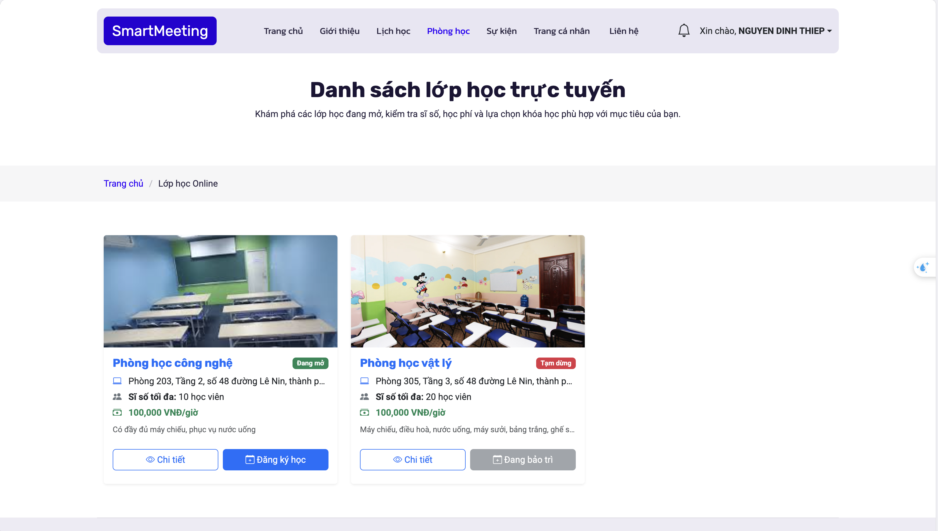
Fig 3.10. Meeting schedule page interface

3.3.3. Location & Contact Integration Module:
By integrating Google Maps API, this module provides users with precise geographical data for physical meeting locations. It also includes an automated inquiry form for direct communication between users and the support team.
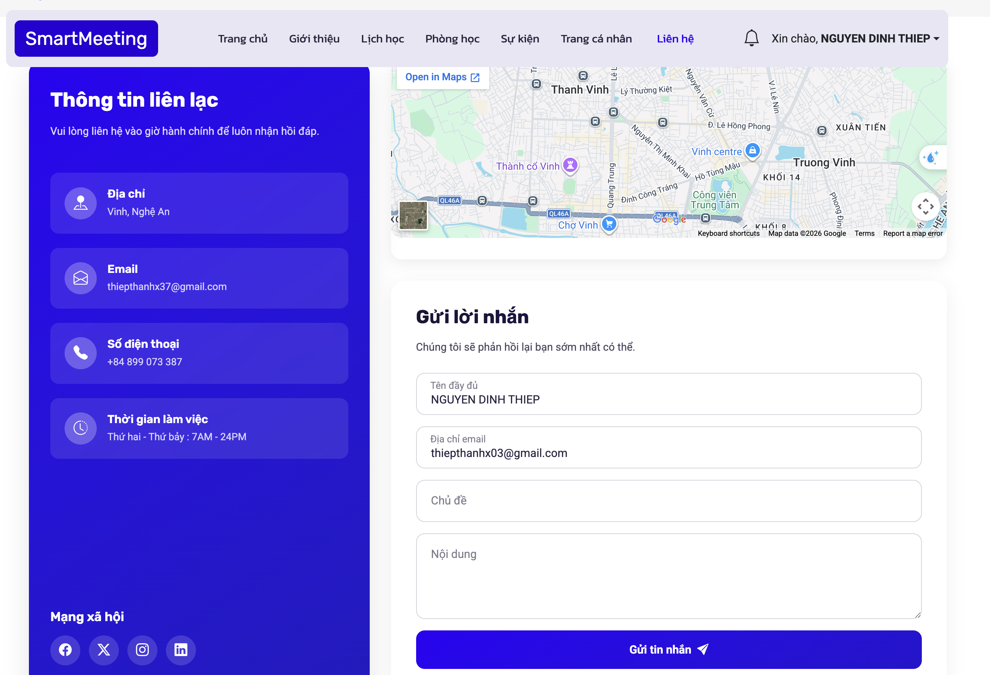
Fig 3.11. Contact page interface

3.3.4. User Account & Profile Module
This module manages personalized data, including user profiles, meeting history, and security settings. A dedicated dropdown menu allows for quick access to "Profile," "Meeting History," and "Privacy Policy."
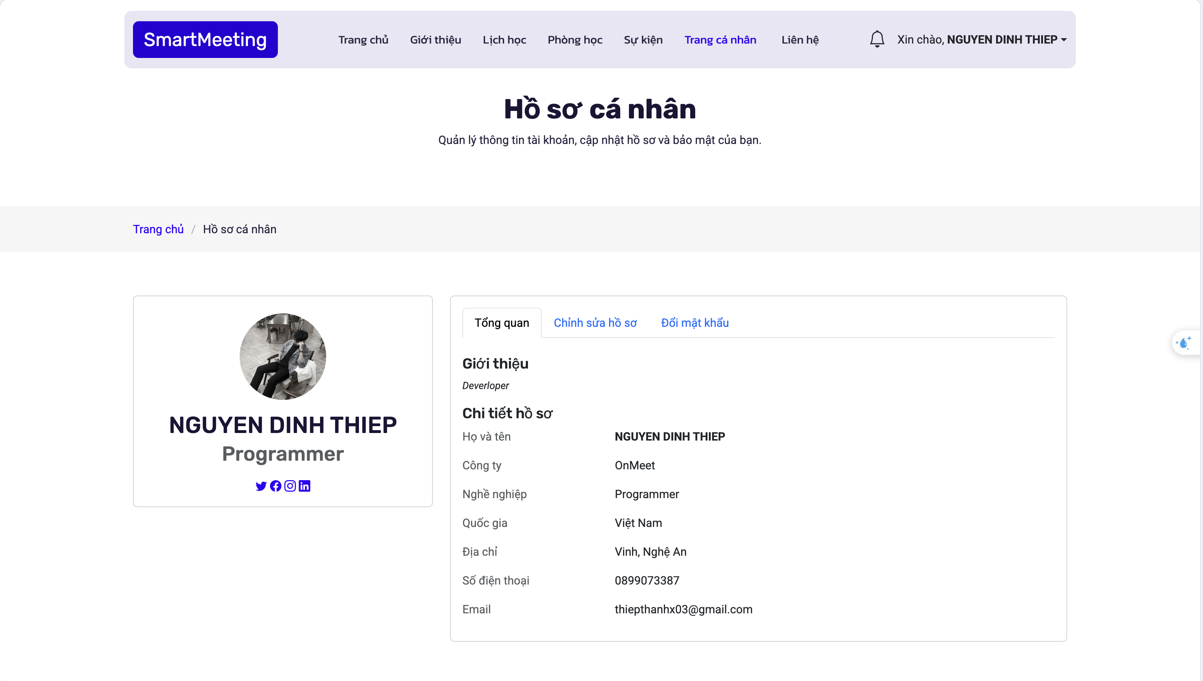
Fig 3.12. Personal profile interface

3.3.5. Admin page for user management
The User Management Interface allows administrators to manage all user accounts within the Smartmeeting Room Management System. This page provides functionalities for viewing, searching, adding, and editing user information efficiently. The interface is designed with a structured table layout to help administrators monitor user data clearly and conveniently.
The system displays important user information such as full name, email address, phone number, and user roles. Role labels such as “ADMIN” and “USER” help administrators easily identify account permissions and manage access control within the system. Additionally, action buttons such as “Edit” enable quick updates to user information and account settings.
The interface also includes a search bar and filtering functions, allowing administrators to quickly find users based on names, email addresses, or phone numbers. The responsive and user-friendly design improves system usability and supports efficient management operations across different devices.
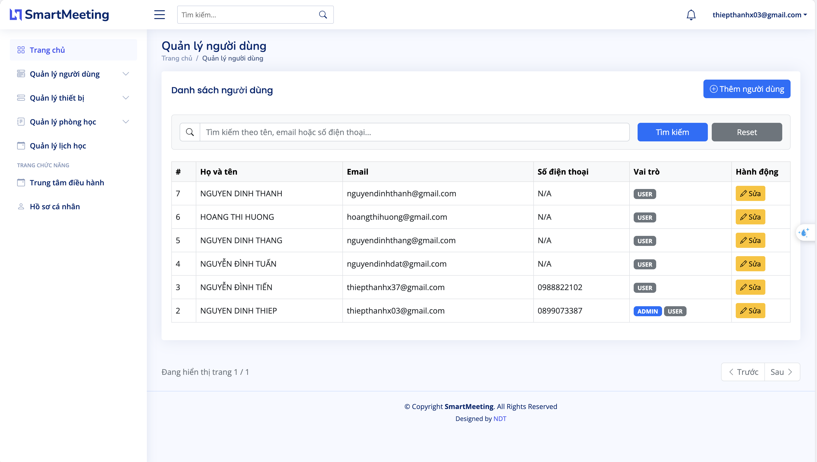

Fig 3.13. Admin page for user management

3.3.7 Devices management admin page
The Device Management Interface allows administrators to manage and monitor all equipment used within the Smartmeeting Room Management System. This page provides functionalities for adding, searching, filtering, editing, and deleting devices efficiently. The interface is designed with a clean and organized layout to help administrators easily track device information and operational status.
The system displays important device information such as device ID, device name, category, availability status, and quantity. Status labels such as “AVAILABLE” help administrators quickly identify which devices are ready for use and support effective resource management. Action buttons such as “Edit” and “Delete” provide quick access for updating or removing device records from the system.
Additionally, the interface includes filtering and searching features that allow administrators to search devices by name, type, or status. This improves management efficiency and helps optimize equipment allocation for meeting rooms and events. The responsive design also ensures smooth usability across different devices and screen sizes.
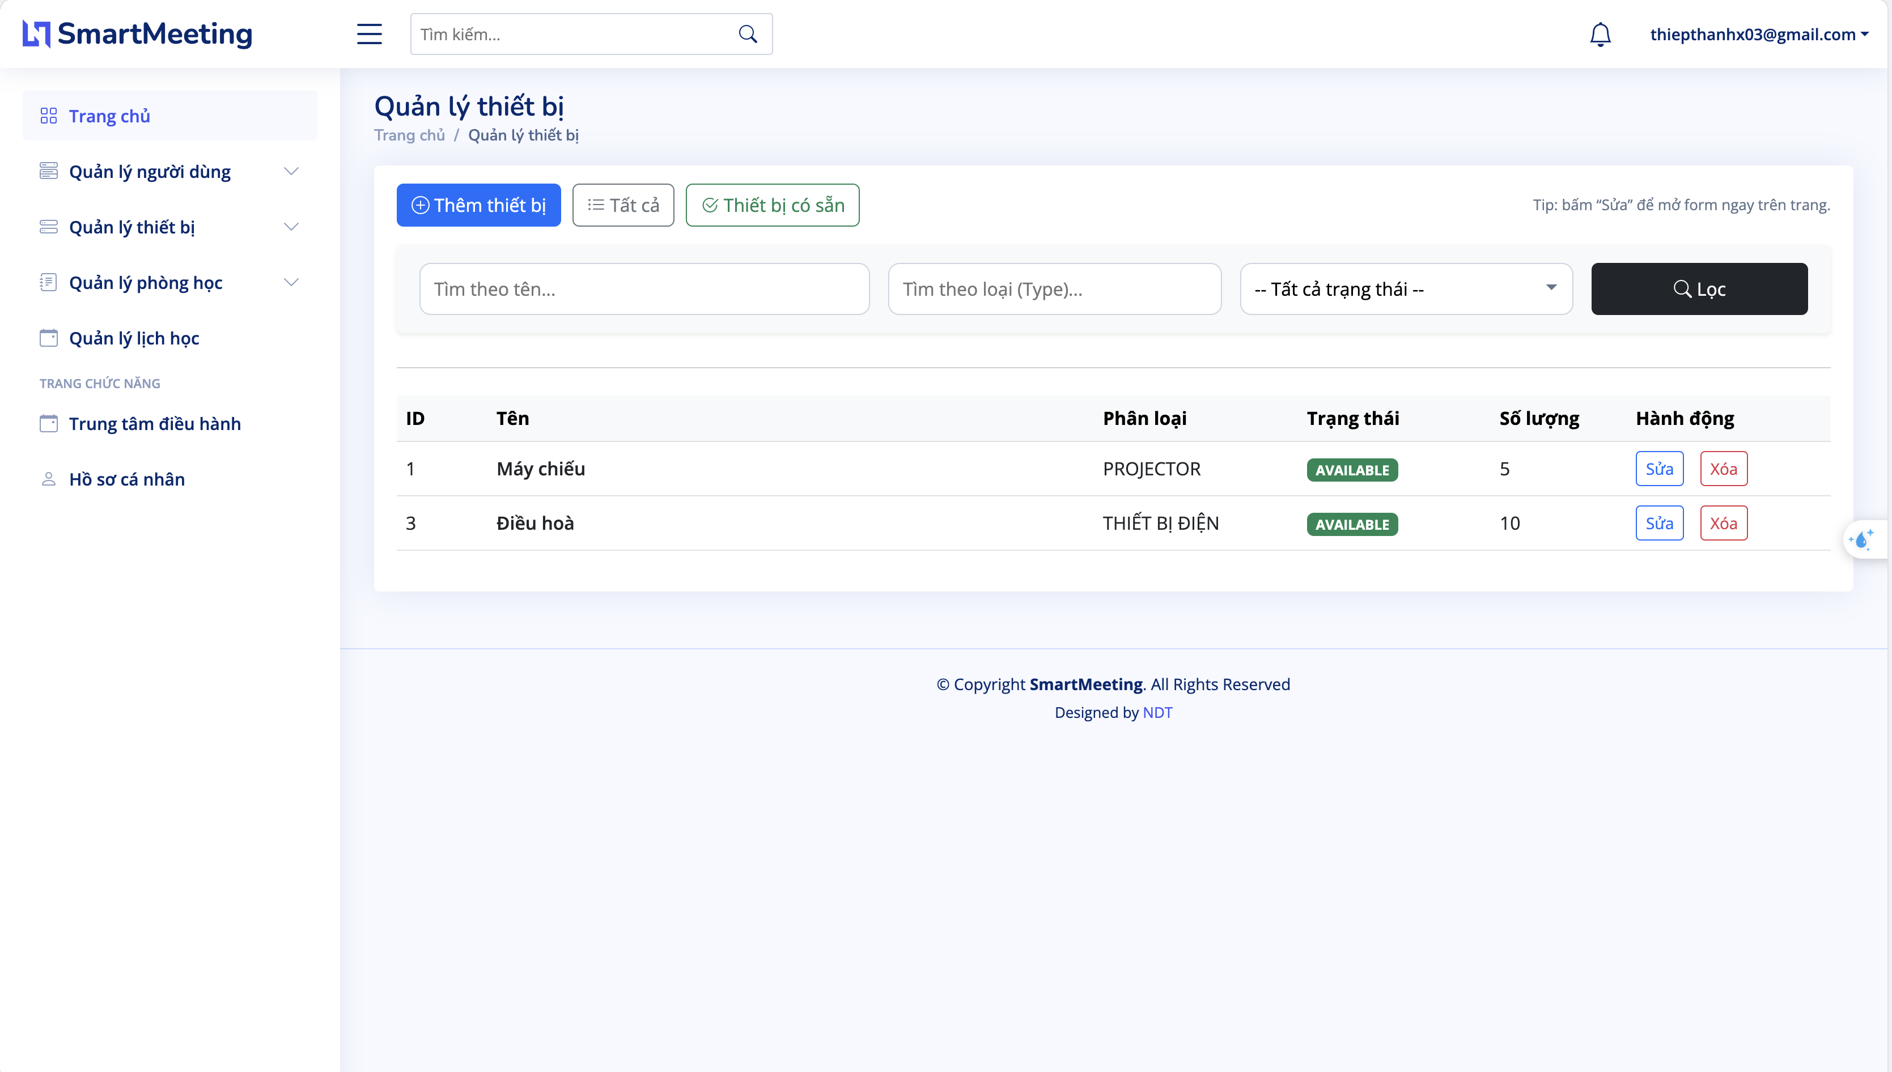
Fig 3.14. Devices management page

3.3.8. Conferences management page
This interface is a core component of the SmartRoom system, acting as a link between administrative management data and the actual classroom usage needs of teachers. The website is divided into two main functional subsystems:
Classroom Information Board: Displays visual images, actual operating status Available/Busy, and technical specifications of the room such as maximum capacity and accompanying facilities Projector, Wi-Fi, etc..
Quick Scheduling and Booking Form: Allows teachers to select an available class from the list and set a specific time frame to assign to that classroom. Notably, the system integrates a "+ Create New Class" button as a modal popup window, allowing teachers to quickly add new classes on the spot without switching pages, optimizing the user experience.
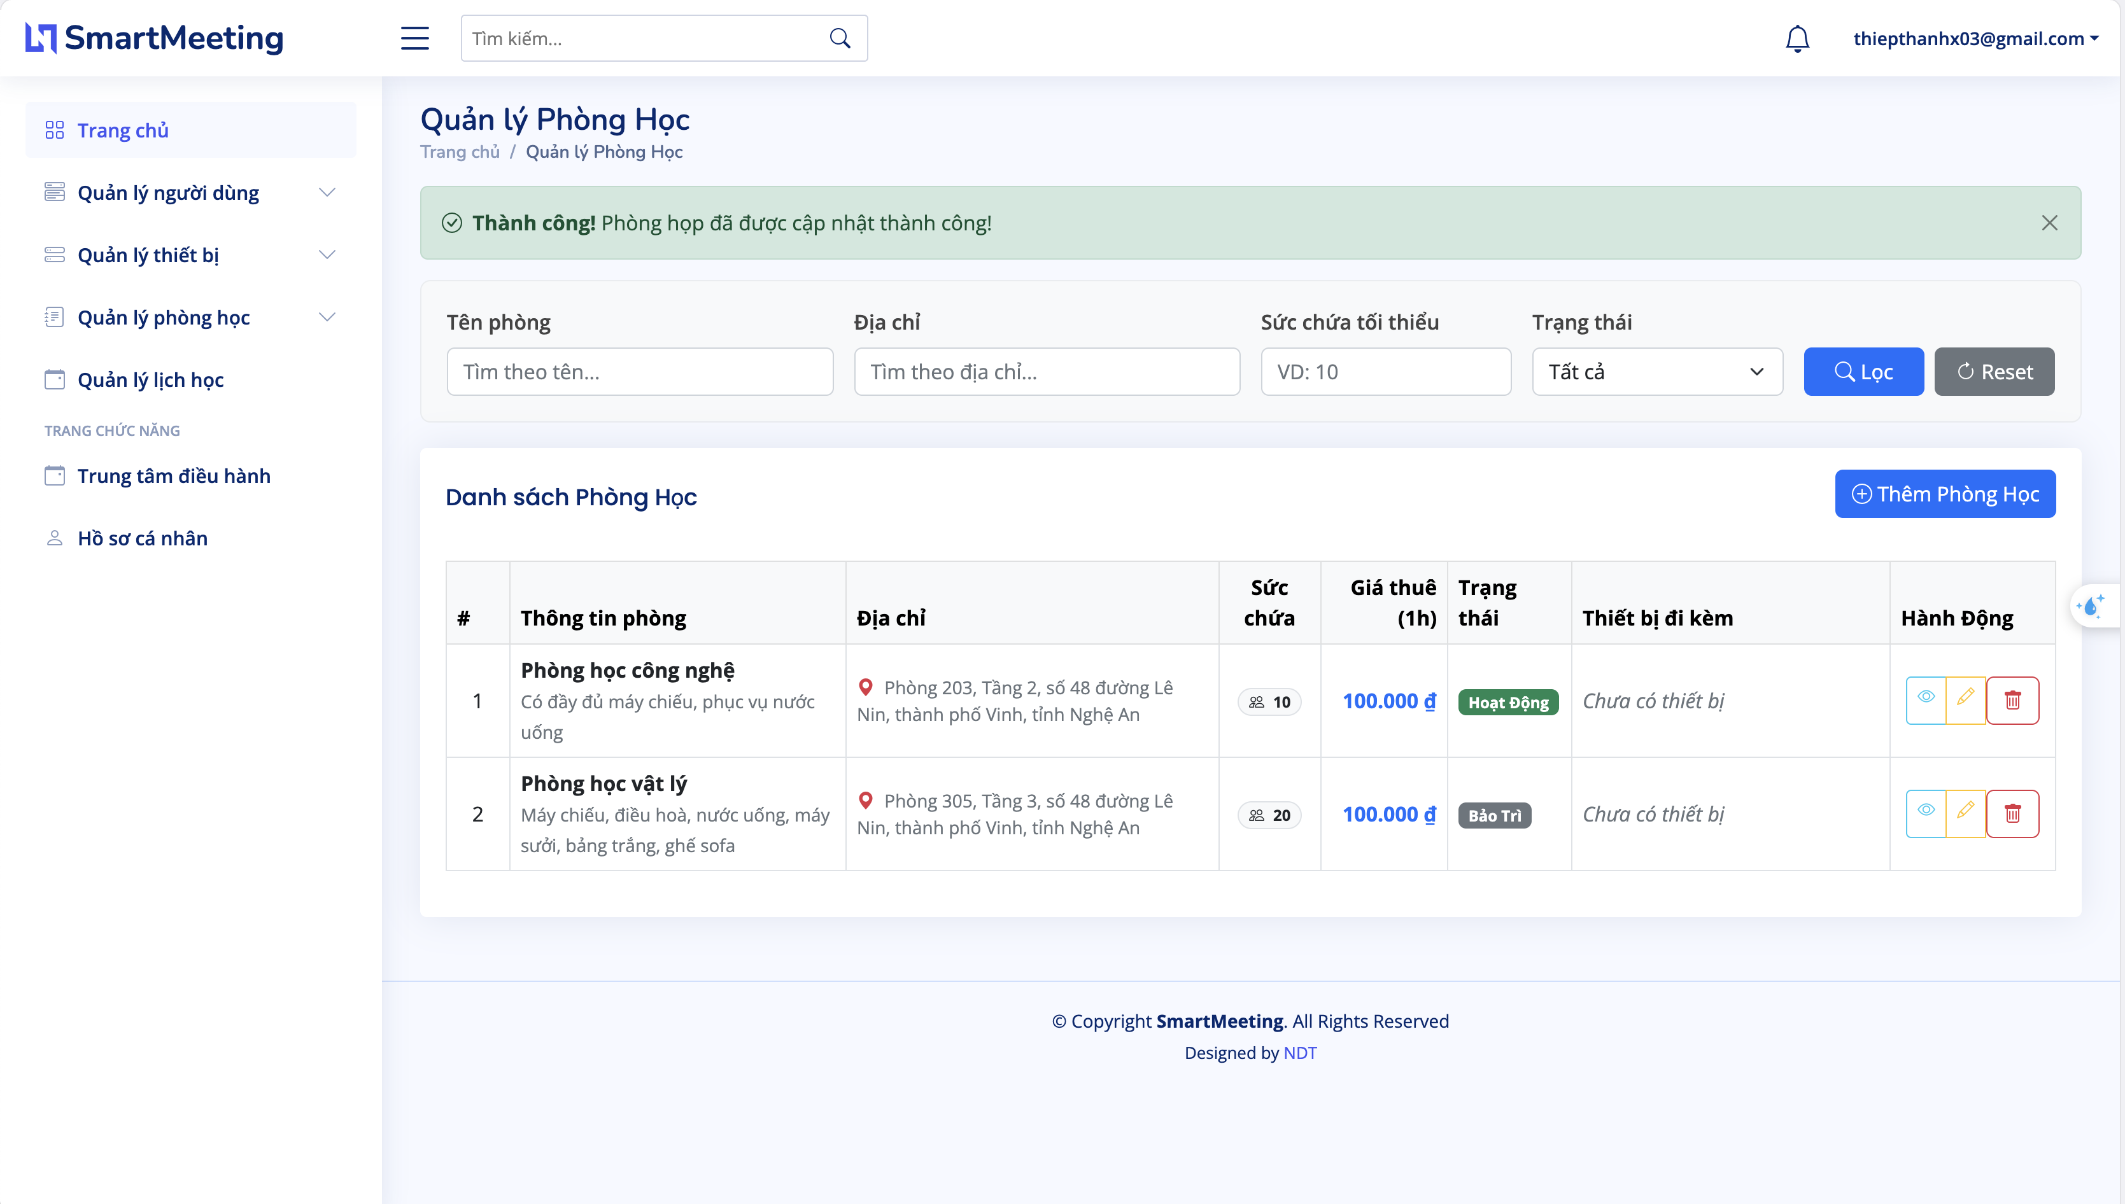
Fig 3.15. Conferences management

3.3.9. Operations center page
This interface is the administration subsystem specifically for authorized users such as Administrators, allowing the creation and configuration of technical parameters for a new classroom before it is put into operation on the SmartRoom system. The website includes the following main components:
Basic Information Input Form: Provides required data input fields including Classroom Name, Maximum Capacity, and a brief description of the room's characteristics.
Assets/Equipment Declaration: Integrates options for the administrator to pre-integrate existing hardware equipment in the room such as Projector, Air Conditioner, Smartboard, automating the synchronization of classroom resources.
Navigation and Action Confirmation System: Includes a "Create" button sends an HTTP POST request to validate data before saving to the MySQL database and a "Cancel" button that allows users to cancel the action and return to the classroom list page without compromising data security.
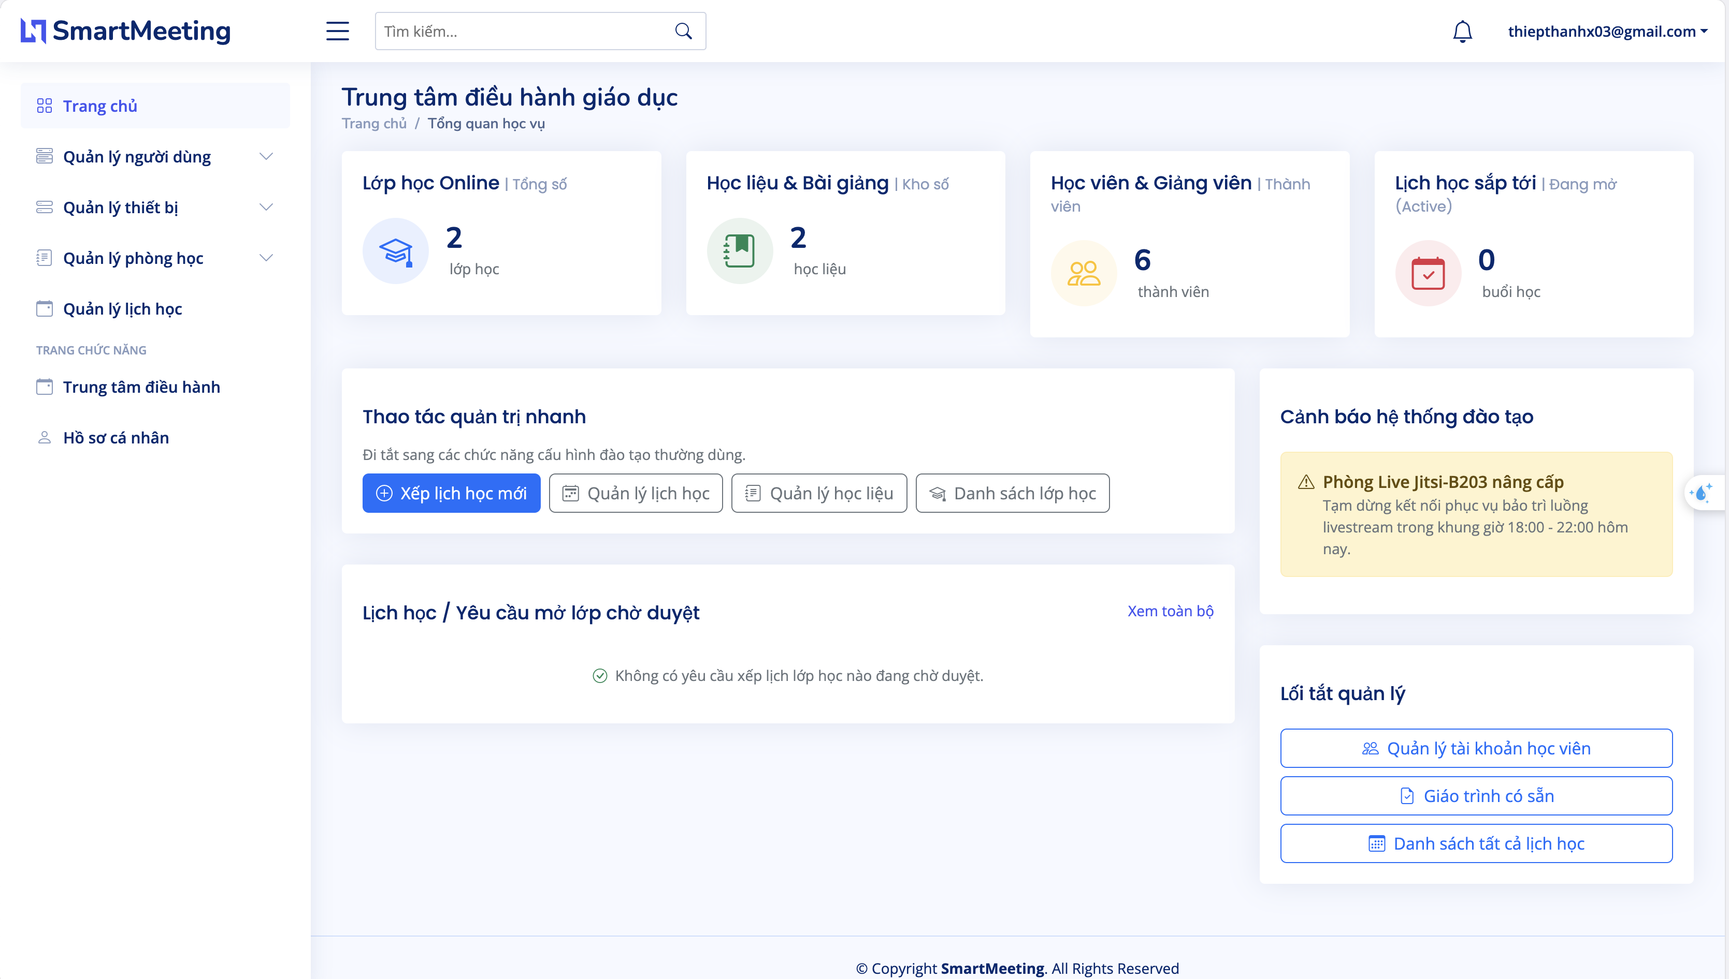
Fig 3.16. Operations center

3.3.10. class schedule management
This interface serves as the main dashboard of the SmartRoom system. It displays an overview of all classrooms both physical and virtual currently available on the system, allowing users to easily monitor, search, and access them quickly.
The website includes the following core components:
System Navigation Bar: Contains the main functional menus such as Dashboard, Rooms, Schedules, Users, Settings allowing users to quickly switch between administrative modules without interrupting the workflow.
Smart Filters and Search: Integrates a search bar by room name and conditional filters such as room status, facilities to optimize search speed as the number of classrooms increases.
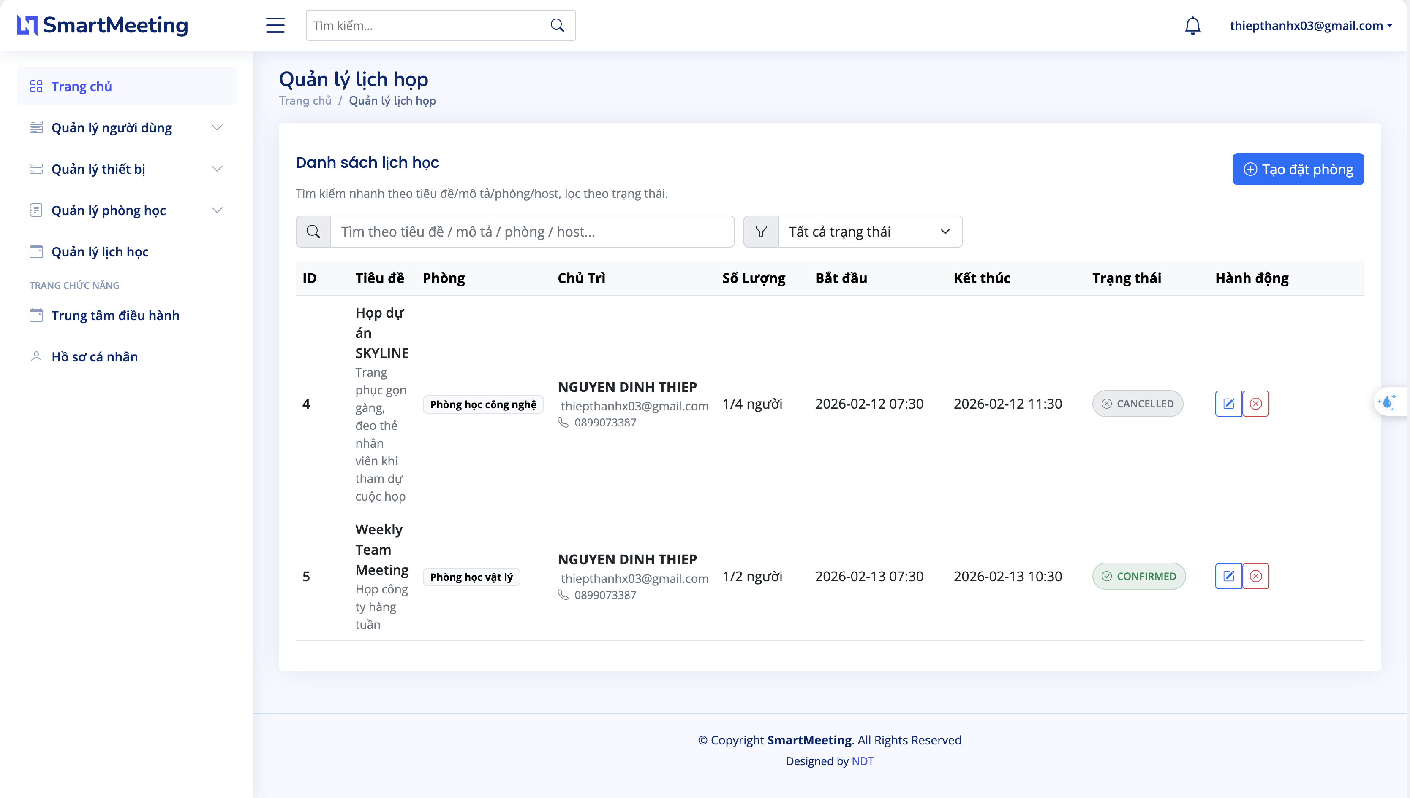
Fig 3.17. class schedule management

3.3.11. classroom details
This page serves as a detailed interactive interface for each specific classroom within the SmartRoom system, optimized into two intuitive sub-systems:
Classroom Asset Information Block:
Identifier: Displays the classroom name along with an illustrative image of the space.
Specifications & Facilities: Lists the maximum capacitym and a list of accompanying hardware equipment such as Projector, Smartboard, Air Conditioner, etc..
Operating Status: Visually displays the current status of the room.
Scheduling/Class Assignment Form Block:
Provides a quick interactive form allowing teachers or administrators to select classes from a pre-configured list.
Set the usage time frame start/end time and add specific notes for the lesson before saving the information to the system.
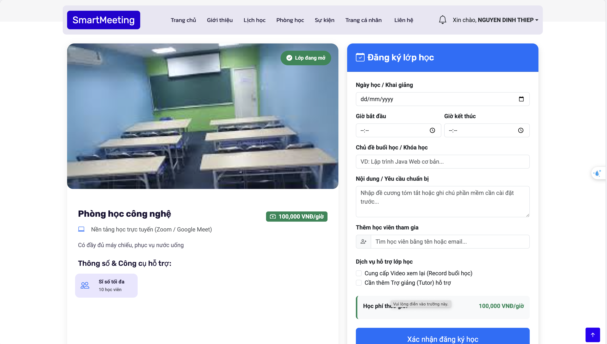
Fig 3.18. Classroom details

3.4. System testing and evaluations
System testing and evaluation were conducted to ensure that the SmartMeeting Meeting Room Management System operates correctly, efficiently, and reliably under different usage conditions. The testing process focused on verifying system functionality, performance, security, usability, and compatibility across multiple devices and environments.
- Functional Testing
Functional testing was performed to validate all core features of the system, including user authentication, meeting room management, device management, meeting scheduling, event organization, and user role management. Each module was tested individually and integrated with other modules to ensure stable communication and accurate data processing.
The testing results showed that the system successfully handled user operations such as creating meetings, managing meeting room schedules, updating device information, and managing user accounts without major functional errors. Input validation mechanisms also worked effectively to prevent invalid data entry and unauthorized access.
- Performance Testing
Performance testing was conducted to evaluate the responsiveness and stability of the system under normal and high workload conditions. The system was tested with multiple concurrent users performing tasks such as searching meeting schedules, updating meeting information, and accessing dashboard statistics.
The results indicated that the system maintained stable performance, fast response times, and efficient database operations. The integration of Spring Boot and MySQL contributed to optimized backend processing and reliable data management.
- Security Testing
Security testing was implemented to verify the protection of user data and system resources. Authentication and authorization mechanisms were tested to ensure that only authorized users could access specific management functions.
The system also applied password encryption, role-based access control, and input validation to minimize security vulnerabilities such as unauthorized access and invalid data manipulation. These security measures helped improve the reliability and safety of the application.
- Usability Testing
Usability testing was performed with users to evaluate the interface design, navigation flow, and overall user experience. Feedback from administrators and users indicated that the system interface was intuitive, easy to use, and visually well-organized.
The responsive design allowed the application to operate effectively across different screen sizes and devices, improving accessibility and user interaction.
- System Evaluation
Based on the testing results, the SmartMeeting Meeting Room Management System successfully achieved the primary objectives defined during the analysis and design phases. The system provides efficient functionalities for meeting scheduling, user management, and device management while maintaining stable performance and security.
Furthermore, the modular architecture built with Java, Spring Boot, Thymeleaf, and MySQL supports scalability and future system expansion. The integration of modern technologies and responsive user interfaces also enhances maintainability and overall user satisfaction.

3.5. Result and discussion
The implementation and testing processes demonstrated that the SmartMeeting Meeting Room Management System successfully achieved the main objectives defined during the system analysis and design phases. The system provided an efficient platform for managing meeting rooms, scheduling meetings, organizing events, and controlling devices within an organization.
The application operated stably under different testing conditions and supported multiple users simultaneously without significant performance degradation. Core functionalities such as user authentication, meeting scheduling, room management, and device management performed accurately and efficiently. The integration between Java, Spring Boot, Thymeleaf, and MySQL also contributed to reliable backend processing and smooth communication between system components.
The user interface was designed with a modern and responsive layout, allowing users to interact with the system easily across different devices and screen sizes. Feedback collected during usability testing indicated that the system was intuitive, visually organized, and convenient for both administrators and regular users. Features such as dashboards, search tools, and management tables improved operational efficiency and simplified management tasks.
In terms of security, the system successfully implemented authentication, authorization, password encryption, and input validation mechanisms. These features helped protect sensitive information and minimized the risks of unauthorized access and invalid data manipulation.
Despite the positive results, several limitations were identified during development and evaluation. The current system mainly focuses on core meeting room management functionalities and still lacks advanced intelligent features such as AI-based scheduling optimization, real-time meeting analytics, and automated notification recommendations. In addition, large-scale deployment and stress testing under enterprise-level workloads have not yet been fully implemented.
For future development, the system can be expanded by integrating Artificial Intelligence technologies to improve scheduling recommendations, meeting analysis, and resource optimization. Additional features such as mobile application support, cloud deployment, video conferencing integration, and advanced reporting systems can also be developed to enhance usability and scalability.
Overall, the SmartMeeting Meeting Room Management System provides a reliable, scalable, and user-friendly solution for modern meeting room management. The project demonstrates the effectiveness of applying modern web technologies and software engineering practices to develop a practical management system that supports organizational operations efficiently.

CONCLUSTIONS

1. Achievements
The development of the Smartmeeting system has been successfully completed, delivering a unified, web-based platform tailored for both infrastructure management and online academic collaboration. Guided by a rigorous software engineering framework, the project has met its primary architectural, functional, and technological goals. The major achievements are summarized below:
Successful Functional Extension and Domain Integration: The system has moved beyond its original room-booking scope to establish an integrated academic management platform. It successfully implements Role-Based Access Control via Spring Security to manage four distinct user experiences: Administrators, Corporate Handlers, Teachers, and Students.
Robust Data Architecture Implementation: A relational database schema using MySQL configured with utf8mb4 for native character persistence was engineered. The data dictionary ensures entity and referential integrity via strict foreign key actions across base user accounts, inventory assets, room scheduling transactions, and detailed multi-tier student assessment metrics academic_records.
High-Performance Real-Time Communication Pipeline: By successfully implementing a dual-protocol runtime engine, the platform achieves low-latency interactivity. It utilizes WebRTC in a Peer-to-Peer configuration leveraging Spring Boot as a signaling facilitator to delegate intensive streaming media overhead. Concurrently, persistent WebSocket connections power instant text communications and direct user notification broad-casting.
Polished and Highly Responsive View Layer: Using Thymeleaf server-side templates coupled with the structural layout properties of the Bootstrap fluid grid system, a clean visual layer was established. The dashboard handles dynamic interface transformations based on active roles while maintaining visual integrity across multiple terminal footprints desktops, tablets, and mobile devices.
Rigorous Engineering Quality Verification: Adhering strictly to the V-Model lifecycle framework ensured that every development increment from requirement definitions to granular structural features underwent parallel testing verification. Validation cycles on a localized infrastructure verified data boundaries, eliminated cross-module regression defects, and confirmed architectural stability under multi-threaded operational scenarios.

2. Limitations
Despite meeting the structural implementation standards, certain operational and architectural boundaries remain outside the scope of the current release due to development window constraints:
Isolated Infrastructure and Standalone Architecture: The system runs as an independent platform. It currently lacks native synchronization hooks or middleware connectors to interoperate with external enterprise Learning Management Systems such as Moodle or Canvas, limiting the portability of student logs and academic course descriptions.
Absence of Automated Media Relaying Handlers: The WebRTC video streaming subsystem relies strictly on basic STUN servers to resolve networking addresses for direct P2P streaming. In heavily restricted enterprise network topologies or behind symmetrical NAT firewalls, the absence of a fallback TURN Traversal Using Relays around NAT server may occasionally hinder media stream initialization.
Lack of Native Mobile Application Extensions: While the presentation layer is highly responsive on mobile browsers via Bootstrap, the system operates completely within a standard web layout shell. It does not provide native mobile operating system features such as hardware-level push notifications or background background sync features found in iOS or Android applications.
Absence of Analytical Automation and Intelligent Modules: All administrative behaviors and student performance tracking rely on manual input and strict database validation. The software lacks advanced automated modules, such as AI-driven identity tracking for attendance verification, automated evaluation anomaly detection for grades, or intelligent booking optimization engines.

3. Future Development
To address the current limitations and enhance the market viability and enterprise readiness of SmartRoom, future development efforts will focus on the following milestones:
Implementation of LTI Compliance and LMS Integration: Future iterations will aim to adapt the backend architecture to comply with the Learning Tools Interoperability standards. This will enable secure, plug-and-play synchronization with global academic infrastructures like Canvas and Moodle, permitting automated grading synchronization and uniform roster imports.
Deployment of Enterprise Media Relay Topologies: To guarantee connection reliability under any structural network constraints, the signaling layer will be paired with a distributed TURN infrastructure such as Coturn. Additionally, incorporating a Selective Forwarding Unit like Kurento or Janus will allow the system to efficiently handle large-scale, multi-party video conferencing without overloading client-side hardware.
Development of Hybrid and Native Mobile Frameworks: The system will look to extend its presentation layer by packaging core micro-frontends into hybrid application solutions such as Progressive Web Apps - PWA or developing native mobile client shells. This will allow the integration of background processes, local biometric authentication, and persistent system alert push capabilities.
Integration of Intelligent and Automated Analytics: Future modules will aim to introduce lightweight, data-driven analytical tools. This includes adding automated data visualization boards to track long-term classroom grading distributions, machine learning scripts to automatically flag class attendance anomalies, and predictive heuristics to optimize physical room and asset allocation schedules during peak academic terms.

REFERENCES
[1] Lê Văn Phùng, Kỹ nghệ phần mềm, NXB Thông tin và Truyền thông, 2014.
[2] Lê Văn Phùng, Lê Hương Giang, Kỹ nghệ phần mềm nâng cao, NXB Thông tin và truyền thông, 2015.
[3] Đoàn Văn Ban, Nguyễn Thị Tĩnh, Giáo trình phân tích thiết kế hệ thống hướng đối tượng bằng UML, NXB Đại học sư phạm, 2011.
[4] Ian Sommerville, Software Engineering, Tenth Edition, Pearson, 2016.
[5] Scott Tilley, Harry J. Rosenblatt, Systems Analys and Design, Shelly Cashman Series, 11th Edition, 2016.

Bảng điểm đánh giá cá nhân
Tên lớp học phần: Công nghệ phần mềm, nhóm: 3

STT | Họ tên | Mã SV | Lớp | Nhận xét chi tiết về đóng ghóp của thành viên nhóm | Mức độ đóng góp | Điểm
1 | Nguyễn Đình Thiệp (NT) | 225748020110281 | 63K CNTT- CLC | Code backend API user và admin, chức năng phân quyền và bảo mật. Code Thiết kế giao diện front-end, thiết kế database, làm báo cáo. Code chức năng call video | Đóng góp rất nhiều | 9.5
2 | Lê Quý Phước | 225748020110101 | 63K CNTT-CLC | Code chức năng quản lý các thiết bị phòng học, quản lý thông báo. | Đóng góp nhiều | 8
3 | Nguyễn Hữu Hưng | 225748020110243 | 63K CNTT-CLC | Code giao diện profile, trang quản lý lịch học. | Đóng góp vừa | 7

Trong đó Mức độ đóng góp ghi như sau (chọn 1 trong các mức và ghi vào):
- Không đóng góp
- Đóng ghóp rất ít
- Đóng ghóp ít
- Đóng ghóp vừa
- Đóng ghóp nhiều
- Đóng ghóp rất nhiều

